Nalu™ TD2 remote control application
user guide
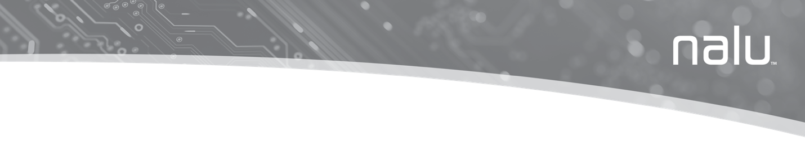

Explanation of Symbols on Product or Package
Refer to the appropriate product for symbols that apply.
Symbol | Title | Explanation | Standard | Reference
 | Manufacturer | Medical device manufacturer, as defined in EU Directive 93/42/EEC | ISO 15223-1 | 5.1.1
 | Date of manufacture | Date when the medical device was manufactured. | ISO 15223-1 | 5.1.3
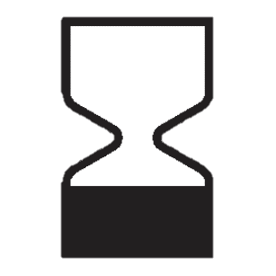 | Use-by date | Date after which the medical device is not to be used. | ISO 15223-1 | 5.1.4
 | Batch code | Manufacturer’s batch code so that the batch or lot can be identified. | ISO 15223-1 | 5.1.5
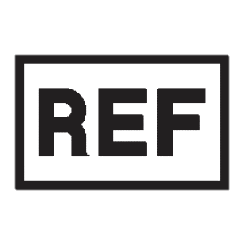 | Catalogue number | Manufacturer’s catalogue number so that the medical device can be identified. | ISO 15223-1 | 5.1.6
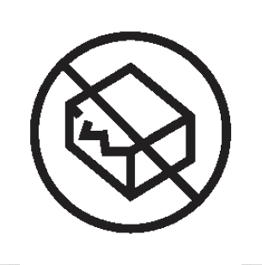 | Do not use if package is damaged | Medical device should not be used if the package has been damaged or opened. | ISO 15223-1 | 5.2.8
 | Keep away from sunlight | A medical device that needs protection from light sources. | ISO 15223-1 | 5.3.2
 | Keep dry | A medical device that needs to be protected from moisture. | ISO 15223-1 | 5.3.4
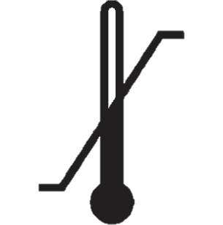 | Temperature limit | The temperature limits to which the medical device can be safely exposed. | ISO 15223-1 | 5.3.7
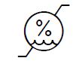 | Humidity limitation | Indicates the range of humidity to which the device can be safely exposed | ISO 15223-1 | 5.3.8
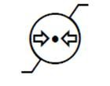 | Atmospheric pressure limitation | Indicates the range of atmospheric pressure to which the device can be safely exposed | ISO 15223-1 | 5.3.9
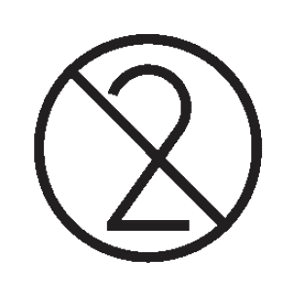 | Do not re-use | A medical device that is intended for one use, or for use on a single patient during a single procedure. | ISO 15223-1 | 5.4.2
 | Consult instructions for use | Indicates the need for the user to consult the instructions for use. | ISO 15223-1 | 5.4.3
 | Refer to instruction manual/booklet. | Indicates the instruction manual/booklet must be read. (This symbol is blue and white on the device label) | ISO 7010:2011 | M002
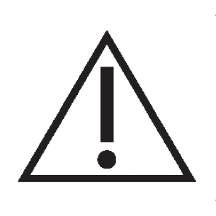 | Caution | User to consult the instructions for use for important cautionary information such as warnings and precautions that cannot, for a variety of reasons, be presented on the medical device itself. | ISO 15223-1 | 5.4.4
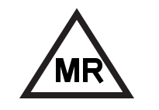 | MR Conditional | Medical device demonstrated safety in the MR environment within defined conditions. | ASTM F2503-13 | Fig. 6
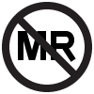 | MR Unsafe | Medical device poses unacceptable risks to the patient, medical staff or other persons within the MR environment. | ASTM F2503-13 | Fig. 9
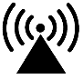 | Radio Transmitter | Device contains a radiofrequency (RF) transmitter, which may cause RF interference with other devices near this device | IEC 60601-1-2:2007 | 5.1.1
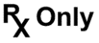 | Prescription use only | Caution: Law prohibits dispensing without prescription | 21 CFR 801.109 | N/A
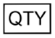 | Quantity | Indicates the total number of products provided in a package. | N/A | N/A
 | Serial Number | Manufacturer’s serial number so that a specific medical device can be identified. | ISO 15223-1 | 5.1.7
 | Best Before | This device is best used before this date. | N/A | N/A
 | Authorized Representative in the European Community | Authorized representative in the European Community | ISO 15223-1 | 5.1.2
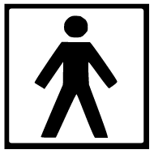 | Protected against electric shock | Device contains a type BF applied part to protect you from shock. The device is internally powered and is intended for continuous operation | IEC 60417 | 5333
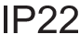 | Protected against access to certain hazardous parts | Protected against solid objects over 12.5mm (e.g., a finger) and protected against falling drops of water, if the case is disposed at any angle up to 15 degrees from vertical | IEC 60529 | N/A
IP68 | Protected from dust and temporary immersion in water | Protected from dust and against effects of immersion in water up to 1m depth for 30 mins | IEC 60529 | N/A
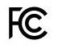 | FCC | This symbol indicates that this equipment has been tested and found to comply with the limits for a Class B digital device, pursuant to part 15 of the FCC Rules. | 47 CFR 2.926 | N/A
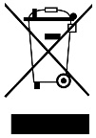 | Do not throw in the trash | This product shall not be treated as household waste. Instead, it is the user’s responsibility to return this product to Nalu Medical for reprocessing. By ensuring that this product is disposed of properly, you will help prevent potential negative consequences for the environment and human health, which could be caused by inappropriate waste handling of this product. The recycling of materials will help to conserve natural resources.  For more information about how to return this product for recycling, please contact Nalu Medical. | BS EN 50419 Marking of Electrical and Electronic Equipment in Accordance with Article 11(2) of Directive 2002/96/EC (WEEE) | Fig. 1

Table of Contents
Indications For Use 9
Introduction 9
Contraindications 10
Warnings 11
Precautions 12
Magnetic Resonance Imaging (MRI) Safety information 13
Document Conventions 14
Nalu Remote Control Application icons and descriptions 14
Application Installation 16
iOS App Installation 16
Android App Installation 16
Application Uninstallation 17
First Time Log In 18
Working with The Menu 21
Changing The Pin 22
Choosing A Language 24
Turning the Clinical Mode On/Off 25
The Clinical Mode is for clinician use only. 25
Measuring the impedance 26
MRI Report 30
Logging Out of The Application 31
Protecting access to the Nalu Remote Control App 31
Viewing the About Information 32
Viewing the Device Details 33
Viewing the Green and Blue Therapy Disc Device Details 33
Viewing the Nalu Implantable Pulse Generator Device Details 37
Viewing the Program List 39
Managing Programs 40
Viewing the Program Details Screen 40
Changing the Therapy Amplitude 43
Starting a Therapy Program 44
Starting the Program from the Home Screen 45
Starting the Program from the Program Details Screen 45
Synchronizing Therapy Discs 46
Configuring the Base Station Charger 53
BSC Wi-fi setup reminder 55
Adjusting the BSC LED Brightness 56
Guidelines For Secure Use 57
Troubleshooting 58
Wireless Technology Information 61
Radiofrequency (RF) and Wireless Data Parameters 61
NFC < 5 mm 62
Quality of Service for Wireless Technology 63
Wireless Security Measures 64
Troubleshooting for Wireless and Coexistence Issues 64
Statement of FCC Compliance (FCC ID: 2AMB3-34001-001, FCC ID: 2AMB3-BSC) 65
RF Exposure Statement (FCC ID: 2AMB3-BSC) 66
Contact Information 67

Indications For Use
Spinal Cord Stimulation (SCS)
This system is indicated as the sole mitigating agent, or as an adjunct to other modes of therapy used in a multidisciplinary approach for chronic, intractable pain of the trunk and/or limbs, including unilateral or bilateral pain.
The trial devices are solely used for trial stimulation (no longer than 30 days) to determine efficacy before recommendation for a permanent (long term) device.
Peripheral Nerve Stimulation (PNS)
This system is indicated for pain management in adults who have severe intractable chronic pain of peripheral nerve origin, as the sole mitigating agent, or as an adjunct to other modes of therapy used in a multidisciplinary approach. The Nalu Neurostimulation System for PNS is not intended to treat pain in the craniofacial region.
The trial devices are solely used for trial stimulation (no longer than 30 days) to determine efficacy before recommendation for a permanent (long term) device.

Introduction
This guide is intended for people using the Nalu Remote Control Application (App) device accessory to control therapy sessions for their Nalu Neurostimulation System. This guide provides instructions needed to properly use the App installed on their device.
The Nalu Remote Control Application (App) runs on Android and iOS platforms and is used to control and manage the Therapy Disc and the various settings of the Nalu Neurostimulation System including turning stimulation programs on/off, and adjusting stimulation levels.
The App connects to the Therapy Disc through Bluetooth® Low Energy (BLE). The Therapy Disc connects to the Nalu Implantable Pulse Generator through radiofrequency (RF).
Once installed on your device, setup of the Nalu Remote Control Application must be completed in the presence of and under the guidance of your Nalu Representative using the Nalu Clinician Programming Application. Refer to sections “Application Installation” and “Application Uninstallation” for instructions on installing, updating, and uninstalling the application.

Contraindications
Patients contraindicated for this therapy are those who:
- Are unable to operate the system
- Have failed trial stimulation by failing to receive effective pain relief
- Are poor surgical risks
- Are pregnant

Exposure to shortwave, microwave, or ultrasound diathermy – Diathermy should not be operated within the vicinity of a patient implanted with a Nalu Neurostimulation System or when wearing a Therapy Disc. The energy from diathermy can be transferred through the stimulator and cause tissue damage, resulting in severe injury.
Occupational exposure to high levels of non-ionizing radiation that may interfere with therapy – Patients who regularly work in environments with elevated levels of non-ionizing radiation should not be implanted with the device. The energy in high-level areas can be transferred through the device and cause tissue damage, resulting in severe injury. Examples of environments having high level non-ionizing radiation include the following:
- Radio or cell phone transmission stations
- Facilities using radiofrequency heat sealers or induction heaters
- Electric power infrastructure-controlled environments (i.e., step down transformers or high voltage power lines)

Warnings
For a complete list and explanation of all Nalu Neurostimulation System Warnings and Precautions, please refer to your Patient Guide for the system.
When you are considering additional medical tests or treatments, please share the complete list and explanation of all Nalu Neurostimulation System Warnings and Precautions with your clinician.
Implanted Cardiac or Other Neurostimulation Systems—Patients who have implanted cardiac or other neurostimulation systems should not use the Nalu Neurostimulation System. Electrical pulses from the Nalu Neurostimulation System may interact with the sensing operation of an implanted cardiac or neurostimulation system, causing the system to respond inappropriately.
Painful Stimulation - If you experience painful stimulation do the following:
- For Permanent Therapy Disc – Remove or decrease the stimulation amplitude.
- For Trial Therapy Disc – Disconnect or decrease the stimulation amplitude.
Contact your clinician if this continues to occur.
Do not modify or tamper with the Nalu Neurostimulation System Remote Control application software.

Precautions
Physician Instructions – Always follow the programs and therapy instructions established by your physician. Failure to do so may cause the therapy to be less effective in providing pain relief.
Random Component Failure – Although unlikely, a failure of the Nalu Neurostimulation System is possible due to random component failure. If any part of your Nalu Neurostimulation System stops working or changes how it works, remove the Therapy Disc and contact your Nalu representative.
Remote Control Interference – If interference is suspected during use of the remote control, confirm that the Bluetooth® data transmission is operating properly. If the Nalu Remote Control application is not connecting to the Therapy Disc:
- Terminate the current stimulation program and shut down the Nalu Remote Control application.
- Check for sources of Bluetooth interference in the surrounding area.
- Remove or turn off the source of interference.
- Re-establish the Bluetooth link with the Therapy Disc through pairing.
- Reopen the Nalu Remote Control application and resume the therapy.

Notice: In the event of any serious incident that has occurred in relation to the Nalu Neurostimulation System, the user and/or patient should report the incident to Nalu Medical at +1.760.448.2360 or visit www.nalumed.com

Magnetic Resonance Imaging (MRI) Safety information
Your Nalu implant is MR Conditional which means you may safely receive an MRI examination only under certain conditions. All external components including the Therapy Disc, Wearable Garment, Adhesive Clip and Programmers are MR Unsafe and must not be brought into the MR system room. If you need an MRI examination, tell your physician you have a Nalu implant. Also tell the MRI site personnel you have a Nalu implant when you call to make an appointment and when you arrive for your MRI examination. Show your implant card to the MRI site personnel when you arrive for your MRI examination.

MRI Safety Information (SCS)
For Complete instructions, please refer to the User instructions for use PN: MA-000105

MRI Safety Information (PNS)
For Complete instructions, please refer to the User instructions for use PN: MA-000105

The MRI Safety Information Manual can be found at www.nalumed.com.

Document Conventions
Item | Convention
Commands and keywords | Boldface font
Displays a placeholder for a value | <Italic> font
Information you type | Italic font
Menu items and button names | Boldface font
Additional information, suggestions, or references that require attention from you | 2 Note
An alternate way of performing a task | ?Tip

Nalu Remote Control Application icons and descriptions
Icon | Name/ Description
 | Menu
 | Blue Therapy Disc
 | Green Therapy Disc
 | Nalu Implantable Pulse Generator Device
 | Used to start a program.
 | Refresh
 | Identify
 | Alert
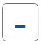 | Used to decrease the therapy amplitude.
 | Used to increase the therapy amplitude.
 | Used to Navigate through program screens
 | Used to stop a program.
 | Represents the most recent stimulation program, press to resume therapy.

Application Installation
The Nalu Remote Control Application can be downloaded from the Apple and Android app stores and installed on both iOS and Android devices. Your Nalu Representative will notify you when a software update is available on the app stores. As updates become available, you should upgrade your application after confirming compatibility with your device OS version. Similarly, you should install OS updates as they are made available by Apple or Google (Android) after confirming compatibility with your remote control application. Consult your representative or contact Nalu Medical Technical Support at 1-800-618-3402 to confirm your device’s OS software version compatibility with the Nalu Remote Control application.
Refer to the App Store or Google Play for the currently supported operating systems.
For other symbols and definitions related to the tablet, phone, refer to the manual provided by the manufacturer.

iOS App Installation
Search for, “Nalu Remote Control” in the App Store and download.

Android App Installation
Search for, “Nalu Remote Control,” on Google Play and download.

Application Uninstallation
To remove confidential Nalu Neurostimulation data from your device, you may simply uninstall the Nalu Remote Control application. Uninstall the app by tapping and holding the app’s icon on your device and then tapping on the remove or uninstall option.
After uninstallation, your device will no longer be able to control and manage your Therapy Disc(s). Reinstalling the application will require the setup completion step with your Nalu Representative again to restore controllability with your Therapy Disc(s).
A Nalu-provided Remote Control device will be securely decommissioned after being returned to your Nalu Representative. Ensure that all personal accounts you may have used with the Nalu-provided Remote Control device are signed out before returning the device.

First Time Log In
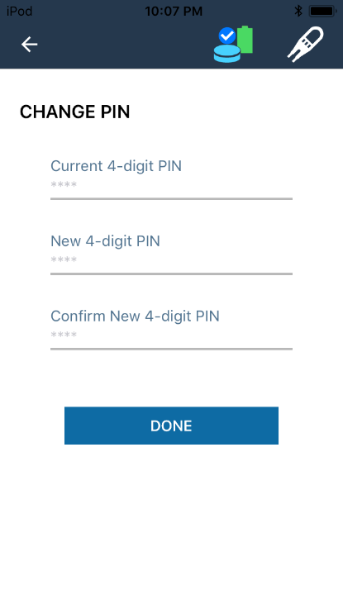
After setting up the application for the first time with the help of your Nalu Representative, you will be redirected to the Change PIN screen.
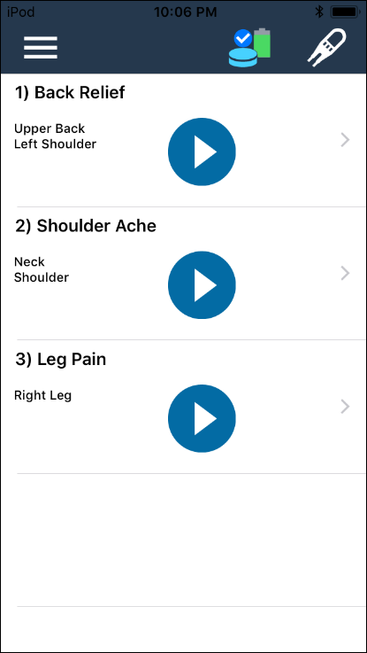

Figure 1 Change PIN for first-time login
Figure 2 Nalu Remote Control Application Home Screen

To change the PIN:
- In the New 4-digit PIN field, type the new PIN.
- In the Confirm PIN field, retype the new PIN.
- Tap Done.
2 | The pin needs to be changed before every 2 years. If the pin is not changed, you will have to contact Nalu and get it reset. Please call 1-800-618-3402 if you need the pin reset.

The PIN will be changed, and you will be redirected to the Home screen as shown in Figure 2.
Page Elements | Description
Menu (1) | Here, you can change the PIN, select a language, turn ON the clinical mode, logout, and view the about details. For more information, see Working with the Menu.
Devices (2) | You can tap on a device to view the device details. It will display the Therapy Disc and the Implantable Pulse Generator device details. For more information, see Viewing the Device Details.
Program list (3) | You can view the list of programs configured for you here. For more information, see Viewing the Program List.
The next time you log into the application, you will see the Login screen as shown in Figure 3.
Figure 3 Login Screen
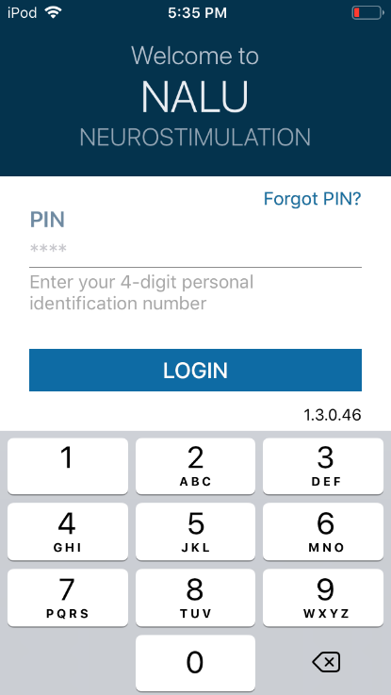

Working with The Menu
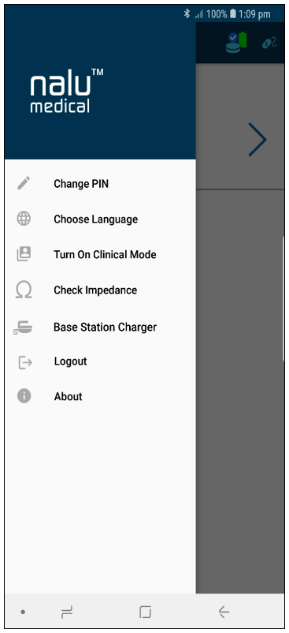
- Tap the icon to view the menu details.
- Using the menu, you can:
- Change the PIN
- Change language
- Turn ON the clinical mode
- Check impedance
- configure the Base Station Charger
- Logout of the application
- view the APP details in About

Figure 4 Menu

Changing The Pin
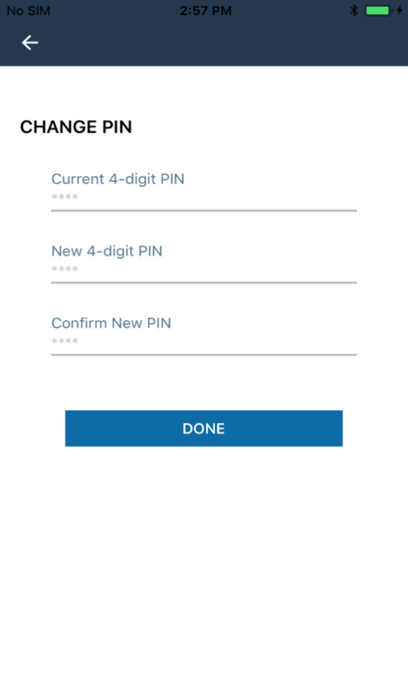
If you want to change the PIN, tap Change PIN in the menu. The Change PIN screen will appear as shown in Figure 5.
Figure 5 Change PIN screen

To change the pin:
- In the Current 4-digit PIN field, type the current pin.
- In the New 4-digit PIN field, type the new pin.
- In the Confirm PIN field, retype the new pin.
- Tap Done.

The PIN will be changed, and you will be redirected to the Home screen.

If you attempt to log in five times with an incorrect PIN, the application will be locked for five minutes, as shown in Figure 6.
You can log in to the application after five minutes,
using the valid PIN.
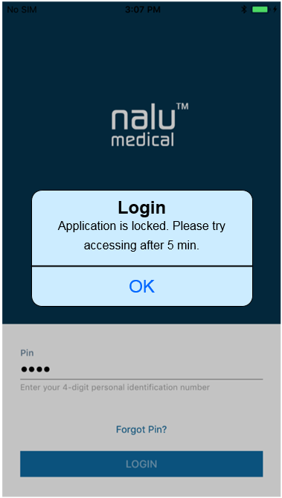
Figure 6 Application locked message

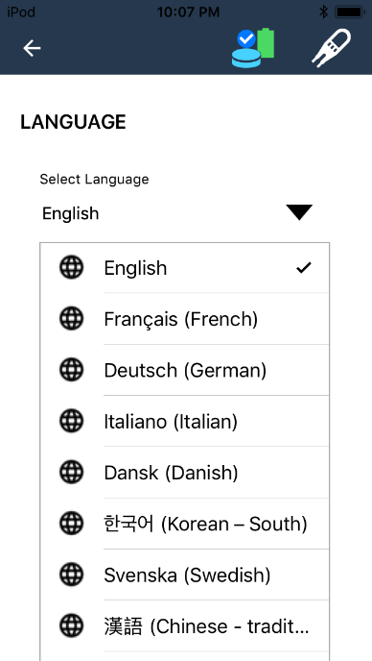
Choosing A Language
Figure 7 Language Selection Screen
You can select English, French, German, Italian, Danish, Korean, Dutch, Portuguese, Swedish, or traditional Chinese from the list of available languages.
To select a language:
- Tap Choose Language on the menu. The Language screen will appear.
- Tap on the Select Language drop-down list.
- Tap on the desired language.
2 | The default language is English.

Turning the Clinical Mode On/Off
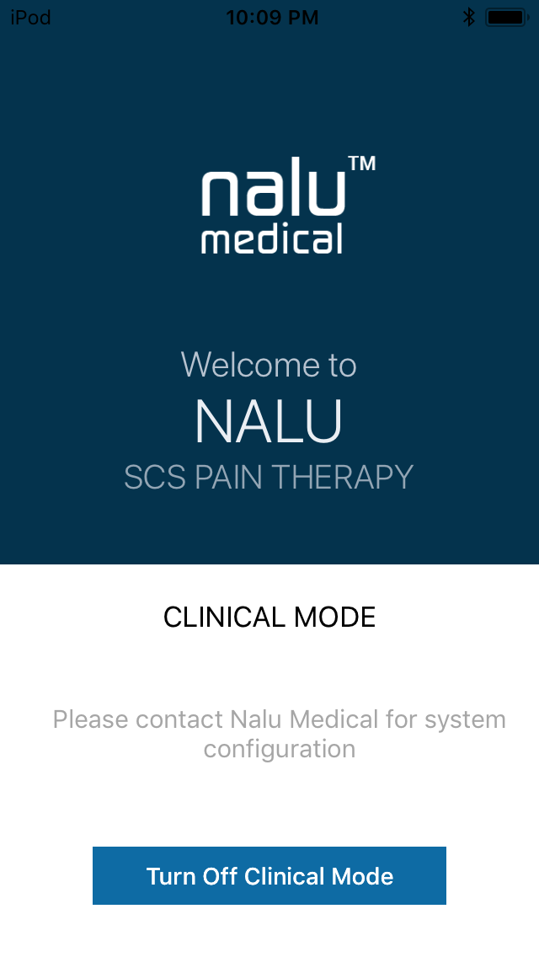
Figure 8 Clinical Mode

The Clinical Mode is for clinician use only.

If you turn on the Clinical Mode, please turn it off by clicking the blue “Turn Off Clinical Mode” button at the bottom of the screen.

Measuring the impedance
To measure the impedance of electrodes,
- Tap on Check Impedance on the menu.
- Tap on the Measure Impedance on the Check Impedance screen.
- Tap on the View Result button. Electrode Impedance screen appears. It displays the most recent Impedance values with date and time.
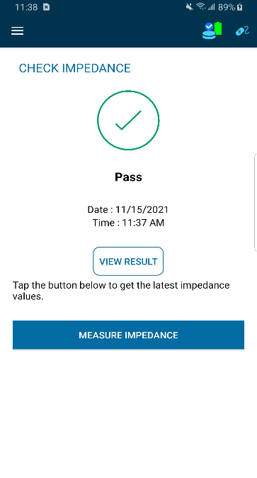  Figure 9 Check Impedance Screen | 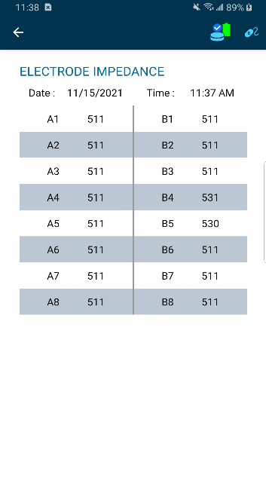  Figure 10 Electrode Impedance Screen

2 You can view the most recent Impedance values for up to 48 hours.

Impedance results can be Pass, Fail and Inconclusive based on the impedance values of the configured electrodes.

Impedance Result | Condition
Pass | If Impedances of the configured electrodes are in-range (0 to 9500 Ω).
Pass | If the number of leads is unspecified by Remote Control and in-range impedances (0-9500 Ω) are detected for electrodes.
Fail | If Impedance of any configured electrodes is above 9500 Ω.
Inconclusive | If the number of leads is unspecified by Remote Control and in-range impedances (0-9500 Ω) are not detected for electrodes.

2 You cannot measure impedance if the IPG/EIC is disconnected before or during an impedance measurement. A notification saying “Please connect IPG/EIC to measure impedance” appears.
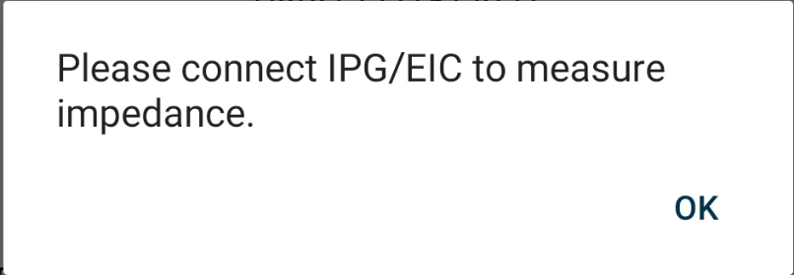
Figure 11 Notification message

MRI Report
The Remote Control application allows the user to view an MRI Report that has been downloaded onto their Permanent Therapy Disc(s) by the Clinician Programmer.
WARNING – The contents of the MRI Report should be cross referenced with the information in the MRI Safety Information Manual (MA-000105). Never rely solely on the MRI Report for MRI Conditionality parameters and information. For patients with more than one Nalu Neurostimulation System, consult the MRI Safety Information Manual. The MRI Safety Information Manual can be found at www.nalumed.com.
To view the MRI Report, tap on MRI Report from the menu.
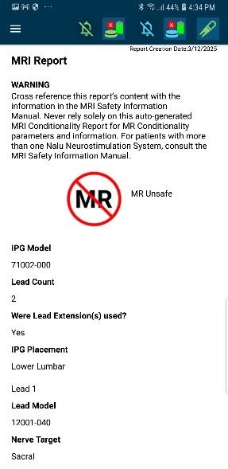
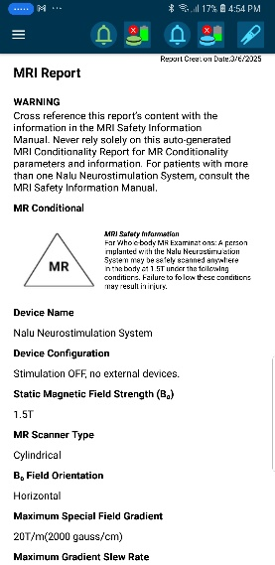
Figure 13 MRI Report – MR Unsafe
Figure 12 MRI Report - MR Conditional
You cannot view the MRI Report if there is no MRI Report data available on the Therapy Disc.

Logging Out of The Application
To log out of the Nalu Remote Control Application, tap Logout in the menu.
You will be logged out of the application and redirected to the Welcome screen.
2 | You will be automatically logged out of the Nalu Remote Control Application if it remains inactive for 5 minutes.

Protecting access to the Nalu Remote Control App
To prevent unauthorized access to your remote-control app, set up a passcode or biometric authentication to your phone or tablet using the instructions provided in the manufacturer’s manual.

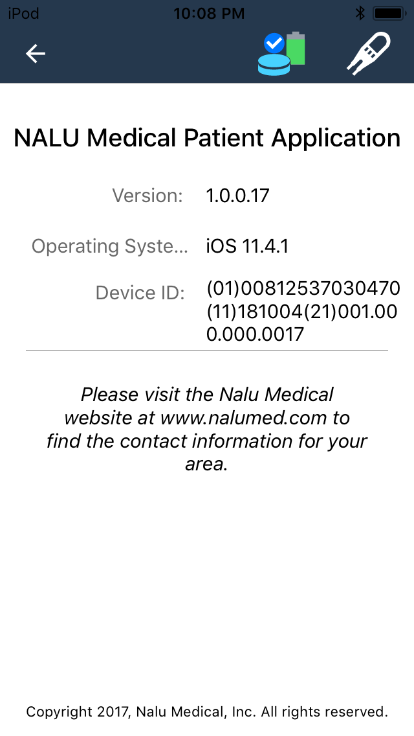
Viewing the About Information
Figure 14 About Screen
To view the Nalu Remote Control Application details:
- Tap About in the menu. The Nalu Medical Patient Application screen will appear.
- The top section of the screen will display the application details, while the bottom section will display the help information that can be used to contact customer service.

You can view the following application details:
- Version
- Operating system
- Device ID
To contact customer service, visit the Nalu Medical website at www.nalumed.com to find the contact information for your area.

Viewing the Device Details
On the Home screen, you can view the devices paired with the Nalu Remote Control App device. You are provided with two Therapy Discs in the initial Nalu Neurostimulation System kit, so that you can use one while the other is charging. Here, you can view the two Therapy Discs (Green and Blue), the paired BSC charger and the Nalu Implantable Pulse Generator. When you tap the Identify icon the Therapy Discs will blink either Blue or Green to help you identify them.
2 | Your Therapy Discs are configured to work with only your implant (Nalu Implantable Pulse Generator) and Remote Control. Your Therapy Discs will not work with another implant or Remote Control, unless they are re-configured by a clinician.

Viewing the Green and Blue Therapy Disc Device Details
Tap the  or  icon to view the green or blue Therapy Disc device details.
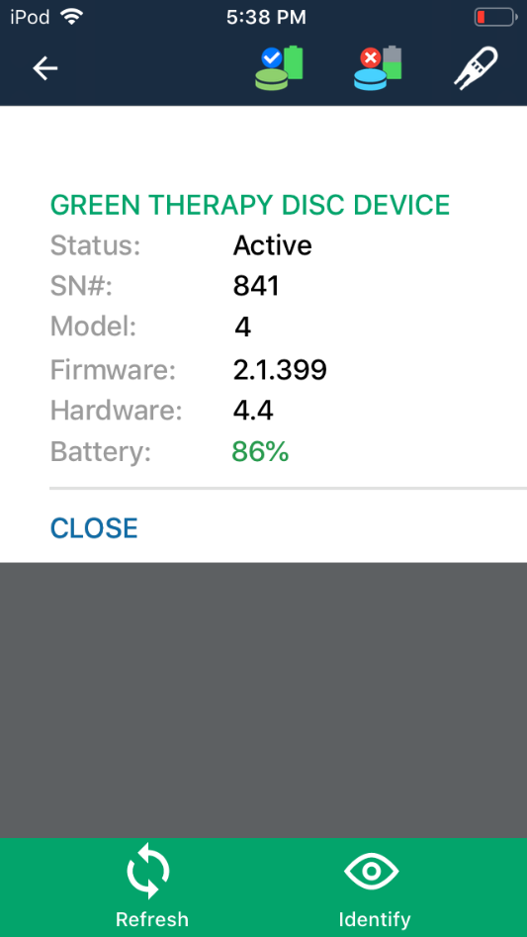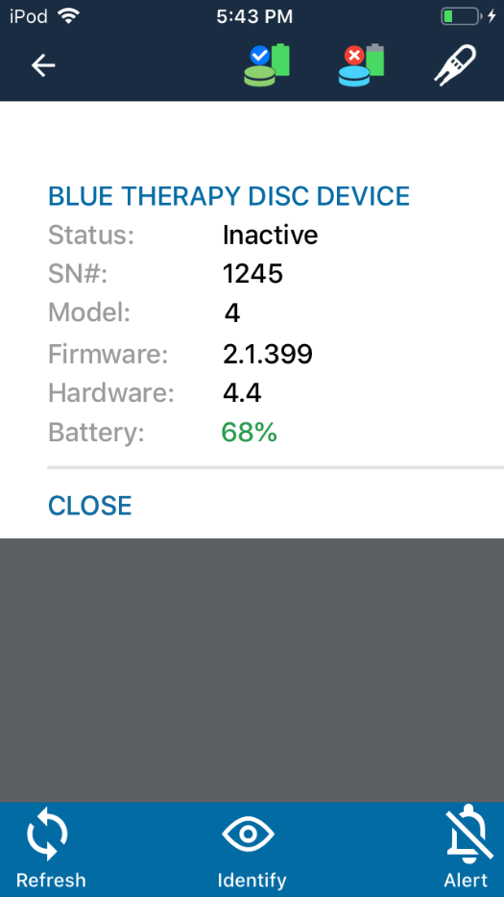
Figure 15 Green and Blue Therapy Disc

You can then view the following details:
Table 2: Green or Blue Therapy Disc details
Field | Description
Status | Displays the status of the Therapy Disc.
Serial number (SN #) | Displays the serial number of the Therapy Disc.
Model | Displays the Therapy Disc model number.
Firmware | Displays the firmware version of the Therapy Disc.
Hardware | Displays the hardware version of the Therapy Disc.
Battery | Indicates the % of battery charge available in the Therapy Disc.
- Tap the Refresh icon to refresh the program information.
- To identify a device from available devices, tap the Identify icon. The identified device will beep, blink, and vibrate.
- Tap the Alert icon to disable alerts.
- To re-enable alerts, tap the icon again.

2 | The Refresh, Identify, and Alert tabs are displayed only if the Therapy Disc is in Active or Inactive Mode. If the Therapy Disc is Unavailable or Busy, then the tabs are not displayed.
- Tap the Close button to close the pop-up.
The status of the green and blue Therapy Discs can be different:
Table 3: Therapy Disc Statuses
Status | Green Therapy Disc Icon | Blue Therapy Disc Icon
Busy | 
Active (Therapy Disc “on” and  actively communicating) |  | 
Inactive (Therapy Disc “on” but not actively communicating) | 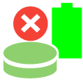 | 
Unavailable (Therapy Discs are either “off” or out of range) | 

Viewing the Nalu Implantable Pulse Generator Device Details
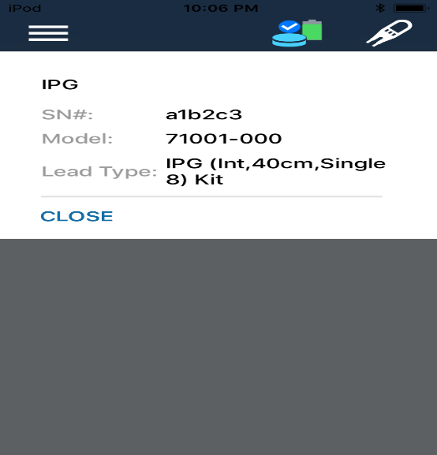
- Tap the  icon to view the
Nalu Implantable Pulse Generator device details.
Figure 16 Nalu Implantable Pulse Generator Device Details

2 | The Nalu Implantable Pulse Generator icon is displayed only if the Therapy Disc is in Active Mode. If it is Inactive, Unavailable or Busy, then the icon is not displayed.

- You can then view the following details:
Table 4: Nalu Implantable Pulse Generator device details
Field | Description
Serial number (SN #) | Displays the serial number of the Nalu Implantable Pulse Generator.
Model | Displays the Nalu Implantable Pulse Generator model number.
Lead Type | Displays the lead type of the Nalu Implantable Pulse Generator.

- Tap the Close button to close the pop-up.

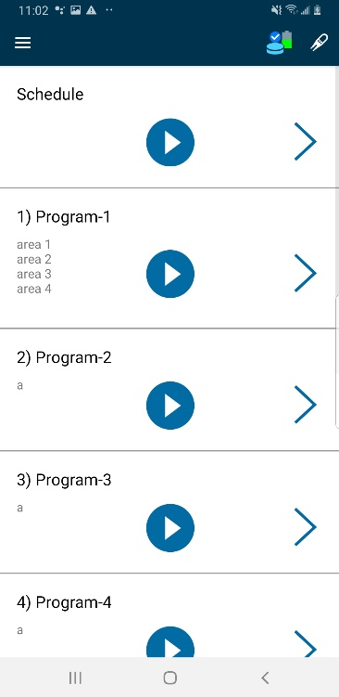
Viewing the Program List
You can view the list of programs configured for you. You can also view program details, such as the program name or program area.
- You can start or stop the program by tapping the  or  icon.
- To view the program details screen,
tap the navigation icon at the right of each program.

If a Session is downloaded onto a patient's Therapy Discs with a Schedule configured, then the RC will display a "Schedule" tab at the top of the Program List screen.
To see what Program is currently running on the Schedule, press the Schedule tab's ARROW button to go to the Program/Area screen. Programs can be executed individually as before by pressing their respective PLAY buttons.
Figure 17 Program List

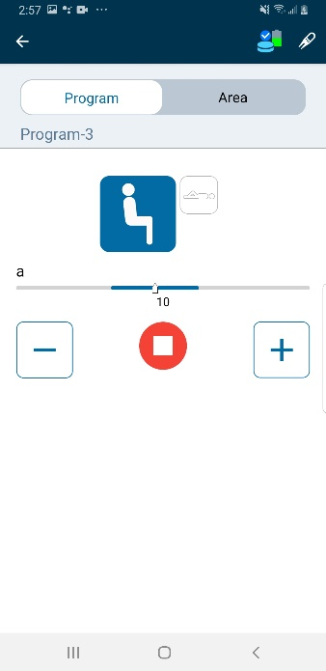
Managing Programs
Figure 18 Program Details Screen

Viewing the Program Details Screen
- On the Home screen, tap on the navigation icon to view the program details screen.

- The Program Details screen displays:
- The Predefined Program Name
- Predefined Program Areas: These names indicate various pain areas.

The Program Details screen also displays the postures available for the program (if your clinician has activated this feature):
Posture Icon | Description
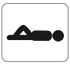 | A variation of this program for supine posture is available.
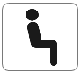 | A variation of this program for upright posture is available.
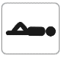 | Not available for this program.
 | Not available for this program.
Table 5: Postures

You can view the range of therapy amplitude (blue) in the progress bar as well.
It also displays and tabs, which you can use to modify the amplitude.
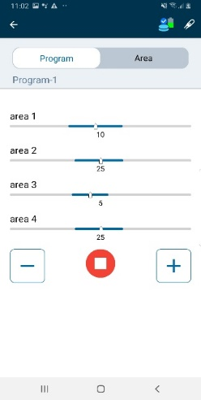
After you start the program by tapping the  or icon, the posture and therapy amplitude tabs will be enabled.
Figure 19 Amplitude and posture tabs enabled

2 | On the Program Details screen, you can change the posture and/or change amplitude - but only if the program is running.
Upon pressing the button, you will see the Program Details screen. For a Schedule, you will see the Program details of the currently stimulating program.

If the + button is pressed once, you will see that all amplitude levels increased by 1. You can interact with each area's amplitudes individually by switching to the "Area" view.
If a Schedule was configured to have idle programs in it, and the Schedule is currently 'executing' that idle program, the RC will display "(Idle)" next to the last executed Program.

Changing the Therapy Amplitude
You can increase or decrease the pulse amplitude percentage by tapping the or button.
If you change the therapy amplitude while running a program, it will start with the most recently selected amplitude and posture when you start the same program again later.
2 | - You can increase or decrease the pulse amplitude only within the specified (blue) range.  - The amplitude bar displayed is not a slider bar.  - You can change the therapy amplitude, but only while the program is running.

Starting a Therapy Program
You can begin the therapy by starting the appropriate program.
2 | Make sure that the Bluetooth options of the Therapy Disc and the Nalu Remote Control App device are ON. If the Bluetooth is disconnected, you will be logged out of the application.
You can begin the therapy in two ways:
- You can begin therapy from the Home screen.
OR
- You can begin therapy from the Program Details screen.

2 | After you tap the or  icon, a ramp up must be completed before the Nalu Remote Control App device can modify the therapy.

Starting the Program from the Home Screen
To start the program from the Home screen:
- Select the program that you want to start.
- Tap the or icon.
- The therapy will start.
2 | - You cannot adjust pulse amplitude while running therapy from the Home screen.  - After you start the program execution, the therapy amplitude will be displayed.

Starting the Program from the Program Details Screen
To start the program from the Program Details screen:
- On the Home screen, select the program you want to execute.
- Tap the navigation icon. The Program Details screen will appear, displaying the posture and pulse amplitude settings.
- Tap or to start the program.
- Select the posture and adjust the pulse amplitude.
- The therapy will start.

Synchronizing Therapy Discs
If you bring only one of your therapy discs to a programming session with a Nalu representative, you may receive an updated list of programs for just that one therapy disc. In this scenario, the therapy discs are considered out of sync.
The Remote-Control application allows you to synchronize your therapy discs’ programs by copying programs from one disc to the other.
Steps to follow to sync discs:
- When the therapy discs connect to the Remote-Control application and the Remote Control detects that they are out of sync, the Sync Discs dialog box appears. See the figure below.
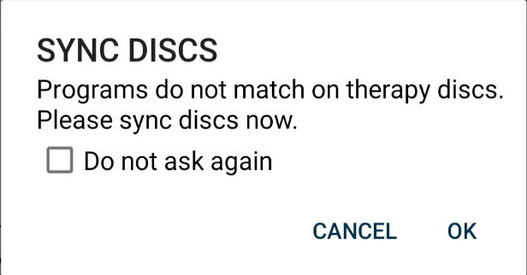
Figure 20 Sync Discs dialog box

- When you tap OK, the Sync Discs screen appears. The default option “Use Newest” is selected.
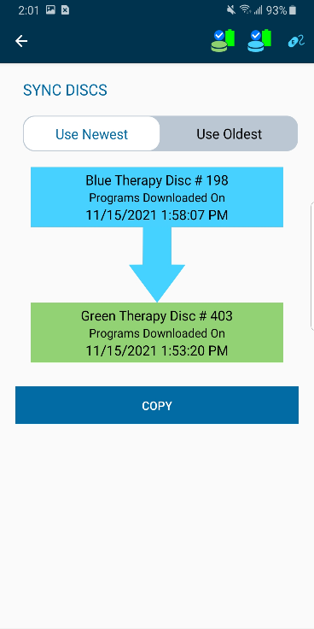
Figure 21 Sync Discs Screen - Use Newest option selected.

- When you tap Copy, “Do you want to copy programs?” dialog box appears.

Figure 22 Do you want to copy programs? dialog box.
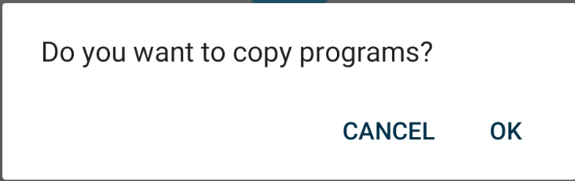
- When you tap OK, the newest programs will be copied to the other disc.

- Once programs are copied, a dialog box saying, “Programs copied successfully!” appears.
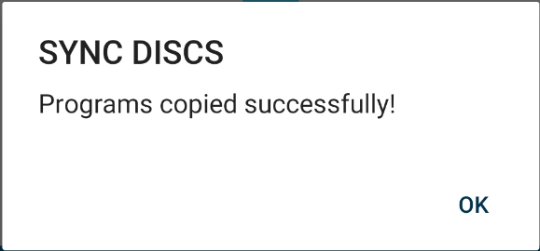
Figure 23 Programs copied successfully dialog box.

- On the other hand, when you select “Use Oldest” option in the Sync discs screen, a warning message appears.
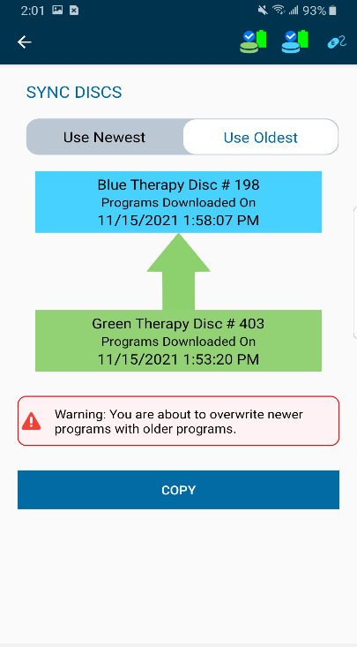
Figure 24 Sync Discs Screen - Use Oldest option selected

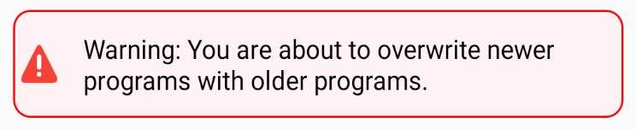
Figure 25 Warning message

- To manually sync discs, tap on either therapy disc’s icon  or , therapy disc device details appear with an option “Sync Discs”. When you tap the “Sync Discs” option, the Sync Discs screen appears.
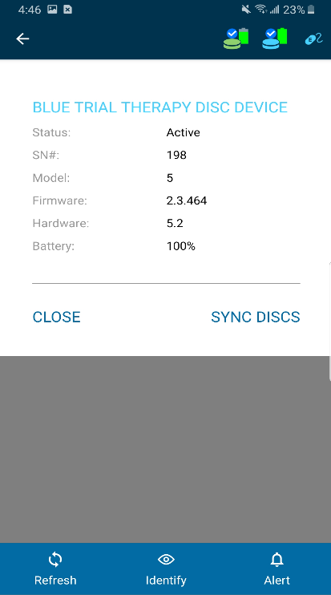  Figure 26 Sync Discs option - blue therapy disc | 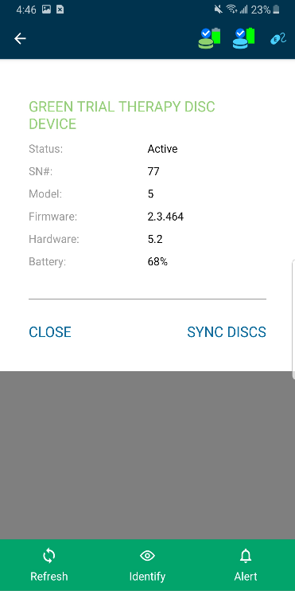  Figure 27 Sync Discs option - green therapy disc

Constraints to follow when syncing discs
- Ensure that both therapy discs do not have a low battery when syncing discs.
  - If either disc has a low battery, a pop-up appears saying, “Low Battery”. Please retry syncing discs after charging them.

- Ensure both therapy discs are turned ON and connected to the Remote Control when syncing discs.
- If both the devices are turned OFF, then a dialog box appears saying, “Please turn on both the therapy discs”.
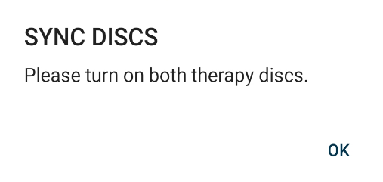
Figure 28 Dialog box

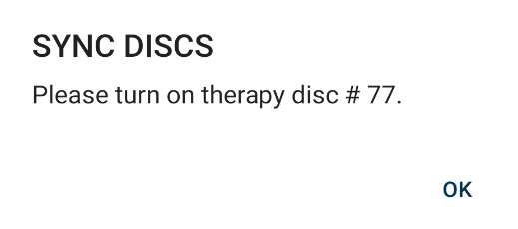
- If one of the devices is turned OFF, a dialog box saying, “Please turn on therapy disc #SN.” appears.
Figure 29 Dialog box

Configuring the Base Station Charger
Before you proceed this process will take you through:
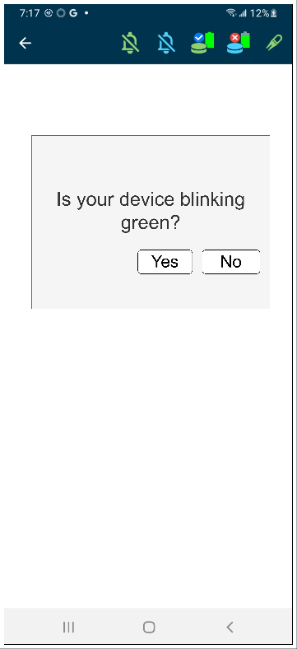
- Connecting the BSC to a Wi-Fi network accessible to your BSC
- You will need the name and password for the Wi-Fi network your BSC will connect to
NOTE: You will be unable to setup if you DO NOT have access to a Wi-Fi connection or do not know the Wi-Fi name or password you are accessing
To configure the Base Station Charger:
- Ensure that Bluetooth is turned on, on the device the RC is running
- Ensure the BSC is plugged in and nearby when setting up.
- You can only setup one BSC at a time
- Tap Base Station Charger in the menu. The Base Station Charger screen will appear.
- The first screen will ask if your device is Blinking green.
- If Your device is blinking you are ready to begin setup, select Yes.
Note: If your device is not blinking or you see other errors like Bluetooth off or one than one BSC, resolve the error and restart
- When selecting yes you will see the Wi-Fi selection screen, NOTE: your network names will match what is available in proximity to you
Figure 30 Dialog box
- Select your Wi-Fi name from the list and have your password ready.
- Once selecting your WiFi enter your password where prompted and select “Save to Charger”
- Please give the Charger time to connect to your WiFi network
- A Setup Complete screen will appear when you have connected.
NOTE: Nalu’s privacy policy can be found at https://nalumed.com/privacy-policy
- See the screen flow below.
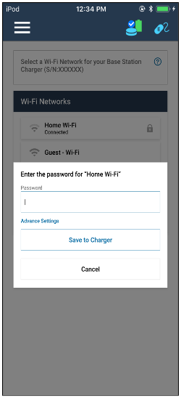
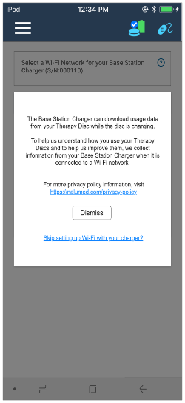
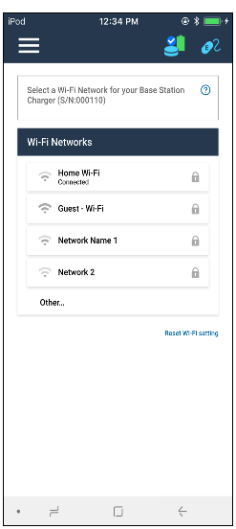
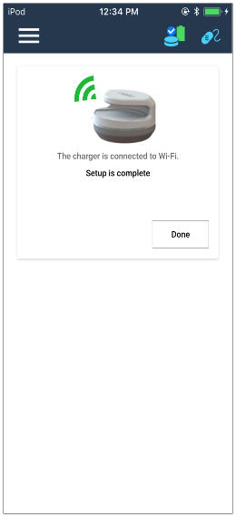
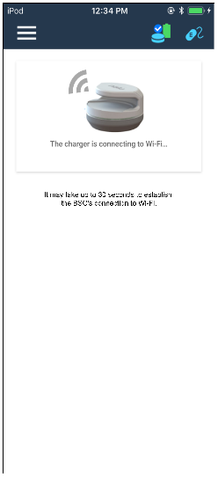
Figure 31 Wi-Fi setup screen flow
If unsuccessful you will be notified and will have to repeat the process from the Main Menu.

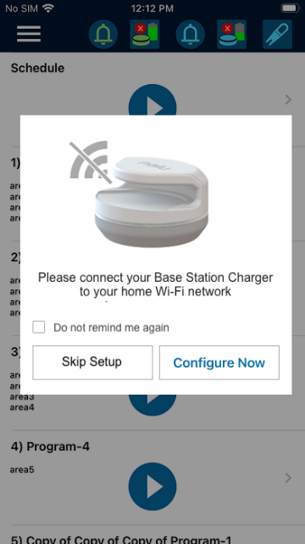
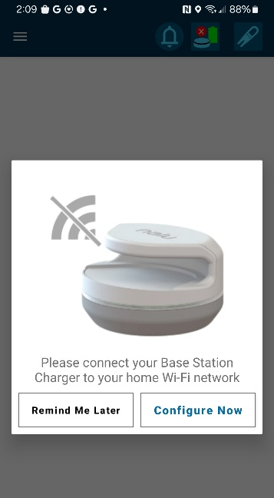
BSC Wi-fi setup reminder
If your BSC is not configured with Wi-Fi, you may run into the BSC Wi-Fi Reminder popup, which looks like the popup depicted on the right.
Tapping the ‘Configure Now’ button will take you to the BSC setup screen, where you can follow the steps in the previous section ‘Configuring the Base Station Charger’.
If you wish to defer configuring the BSC with Wi-Fi, you may tap the ‘Remind Me Later’ option to dismiss the popup.
The RC will remind you again later to connect your BSC to Wi-Fi, according to the following schedule:
Figure 33 Skip Setup button
Figure 32 Reminder button
For the first three times, the popup will appear every 24 hours.
For the fourth time and after, the popup will appear every 10 days.
After ten times, the popup on the right will be displayed, with the option to not show the reminder again.

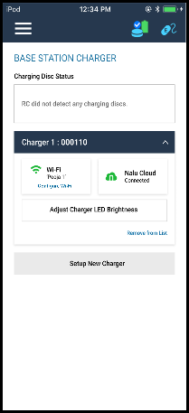
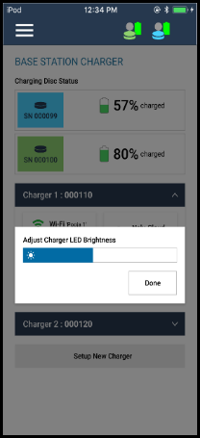
Adjusting the BSC LED Brightness
Once the BSC is connected to Wi-Fi you can Adjust the Brightness of the BSC LED light.
Enter the menu and select Base Station Charger, if the BSC is set up on Wi-Fi the Adjust LED Brightness will be illuminated.
Selected “Adjust Charger LED Brightness” and use the slider to set brightness to your desired selection.
Click done when you are finished adjusting complete.

Figure 35 Brightness slider
Figure 34 BSC menu

Guidelines For Secure Use
Follow these security guidelines when using your remote control device:
- Set up an authentication method on your device (e.g., passcode, facial recognition) and do not share the authentication information with other users.
- Change your RC application PIN frequently and do not share your PIN with other users (refer to “Change the PIN”).
- Do not allow others to use your device.
- Do not install untrusted applications on your device.
- Do not use the application on jailbroken/rooted tablets or phones where users have privileged control of the operating system.
- Do not tamper with or attempt to modify your remote control application.
- When notified by a Nalu Representative, upgrade to the latest remote control application version.
- Install OS upgrades on your device as made available by Apple or Google (Android) after confirming compatibility with the remote control application (refer to “Application Installation”).

Troubleshooting
Therapy Disc
Problem | Causes | Possible Actions
Uncomfortable Stimulation | The selected parameters are not suitable for your activity or posture. | Remove the Therapy Disc from your body.  Unplug the Trial Therapy Disc.  Reduce the stimulation from the Remote-Control Application or the Therapy Disc.
No Stimulation | Stimulation is off. | Place the Therapy Disc in the Base Station Charger and remove.
No Stimulation | Stimulation is off. | Using the remote control, turn stimulation on.
No Stimulation | The Permanent Therapy Disc is not placed over the implant. | Place the Permanent Therapy Disc directly over the implanted Pulse Generator.  Make sure Trial Therapy Disc is plugged in.
No Stimulation | The stimulation amplitude is set too low. | Increase the amplitude.
The Therapy Disc is Unresponsive | The Therapy Disc is not powered ON. | Place Therapy Disc in the Base Station Charger and remove, if the disc remains unresponsive, then leave in the charger for at least one hour and remove.
 | The Therapy Disc functionality is frozen. | Place the Therapy Disc in the Base Station Charger and remove, if the disc remains unresponsive, then leave in the charger for at least one hour and remove
 | The battery is not charged. | Recharge the battery by placing the Therapy Disc on the charger. (may require one hour minimum if fully depleted)
 | Bluetooth connection problem. | Restart the Remote-Control Application.  Restart the Therapy Disc.  Ensure Bluetooth is enabled for the RC app in the Remote-Control device’s settings.
Therapy Disc will not Connect to RC | Bluetooth connection problem. | If above does not resolve, flip the TD from top to bottom 3 times to initiate Bluetooth bond renegotiation.
The Therapy Disc Has Been Dropped | Damage to the device. | Contact your Nalu representative.
The Trial Therapy Disc becomes wet | The Trial Therapy Disc is not waterproof. | Discontinue use of the device and contact your Nalu representative.

Remote Controller Application
When connected to the Therapy Disc/Trial Therapy Disc: Application does not display program list or device status correctly | Connectivity Error | Press the Refresh button.  Log out of the application and log in again.  Shut down the application and restart.  [Therapy Disc] Place the Therapy Disc over the implant.  [Trial Therapy Disc] Disconnect and reconnect the EIC.

Wireless Technology Information

Radiofrequency (RF) and Wireless Data Parameters
Bluetooth® Low Energy (BLE)– Clinician Programmer, Remote Control, Therapy Disc, Base Station Charger
Industrial, Scientific, & Medical (ISM) – Therapy Disc, Nalu Implantable Pulse Generator
Qi Inductive Charging- Therapy Disc, Base Station Charger
Near-Field Communication (NFC)- Therapy Disc, Base Station Charger
WiFi- Base Station Charger
Nalu’s use of wireless technology for system operation are believed to be compatible with regulations worldwide.
Parameter Band Description
Frequency BLE 2.402-2.480 GHz (data) ISM 40.66-40.70 MHz (power and data transfer)
WiFi 2.402-2.480 GHz, 5.150-5.850 GHz
Qi 100-200 kHz
NFC 13.553-13.567 MHz
Bandwidth BLE 2MHz ISM 1 MHz (low-depth amplitude modulation)
WiFi 160 MHz max
Qi < 10 kHz
NFC 14 kHz
Power BLE 10 dBm max ISM -14.1dBm max EIRP (330 mW max conducted)
WiFi 23 dBm max
Qi 10 W max conducted
NFC 420 mW max conducted
Data transfer BLE 1000-2000 kbps, 6ms latency, CRC, encryption ISM 250kbps, 32-bit CRC protection
WiFi 160 Mbps, 32-bit CRC protection, encryption
Qi N/A
NFC 848 kbits/s, ASK/subcarrier load modulation
Effective Range BLE <3meters ISM <3 cm
WiFi < 30 m
Qi < 5 mm

NFC < 5 mm

FCC ID
Therapy Disc | FCC ID: 2AMB3-34001-001  Contains FCC ID: 2AAQS-ISP1507 or 2AAQS-ISP1807
Trial Therapy Disc | Contains FCC ID: 2AAQS-ISP1507
Base Station Charger | FCC ID: 2AMB3-BSC

Classification per IEC 60601-1: Therapy Disc and Trial Therapy Disc
In use | Type BF
Charging | Class II

Quality of Service for Wireless Technology
The Nalu system makes use of several wireless functions during normal operation and for recharging the battery. Detailed wireless parameters are listed in the RF and Wireless Parameters section. Between the Therapy Disc and the IPG, a wireless connection is established using the ISM band. This is a short-range link that powers and communicates with the IPG. Bluetooth Smart wireless technology enables communication between the Remote Control App, Clinician Programmer, and the Therapy Disc. The requirements for the quality of service (QoS) vary depending on the use environment (operating room, recovery room, and home environment).
After the Clinician Programmer or Remote Control App is paired with a Therapy Disc, the Bluetooth wireless technology symbol is visible on the app in the upper right-hand corner of the screen. When the Bluetooth Smart wireless technology connection is not active, the symbol appears dimmed. The standard Bluetooth Smart wireless technology data rate is 1 Mbit/s. Other requirements include a semi-duplex transmission with a required acknowledge, a transmission latency in each direction (2x), and a receive-to-transmit mode (RX-to-TX) time. Data is resent if not sent successfully.
The Base Station Charger uses an inductive charging link using a short-range Qi protocol to recharge the battery on the Therapy Disc. The Base Station Charger also incorporates an optional near-field communication (NFC) technology, a BLE link, and a Wi-Fi connection. Qi and NFC are short-range links that operate when the when the Therapy Disc is inside the charger. NFC, BLE, and Wi-Fi are used to collect non-identifying device information.
When using wireless technology in the presence of high interference, the user may experience delays or disruptions to wireless services. For information on how to improve connection issues, refer to the Troubleshooting for Wireless and Coexistence Issues section.

Wireless Security Measures
The wireless signals are secured through device system design that includes the following:
- The Therapy Disc will encrypt its wireless communication.
- Only one Remote Control App may communicate with the Therapy Disc at the same time.
- A unique key for each Remote-Control App to Therapy Disc connection.
- Built-in pairing that specifies valid and legitimate pairing among units.
- Proprietary authentication in addition to the pairing procedure specified in Bluetooth Smart wireless technology.
- A proprietary algorithm that detects and prevents an unauthorized user from attempting to communicate with the Therapy Disc.

Troubleshooting for Wireless and Coexistence Issues
If you experience issues with the wireless communication between the Remote-Control App and the Therapy Disc, try the following:
- Decrease the distance between the devices to ensure that the devices are within their effective range.
- Move the devices so they share line of sight.
- Move the devices away from other devices that may be causing interference.
- Wait a few minutes and try connecting again.
- Do not operate other wireless devices (i.e., laptop, tablet, mobile phone, or cordless phone) at the same time.
NOTE: Wireless communications equipment, such as wireless home network devices, mobile and cordless telephones, and tablets, can affect the device.

Statement of FCC Compliance (FCC ID: 2AMB3-34001-001, FCC ID: 2AMB3-BSC)
This equipment has been tested and found to comply with the limits for a Class B digital device, pursuant to part 15 of the FCC rules. These limits are designed to provide reasonable protection against harmful interference in a residential installation. This equipment generates, uses, and can radiate radiofrequency energy and, if not installed and used in accordance with the instructions, may cause harmful interference to radio communications. However, there is no guarantee that interference will not occur in a particular installation. If this equipment does cause harmful interference to radio or television reception, which can be determined by turning the equipment off and on, the user is encouraged to try to correct the interference by one or more of the following measures:
- Reorient or relocate the receiving antenna.
- Increase the separation between the equipment and receiver.
- Connect the equipment into an outlet on a circuit different from that to which the receiver is connected.
- Consult the dealer or an experienced radio/TV technician for help.
This device complies with Part 15 of the FCC Rules. Operation is subject to the following two conditions:
- This device may not cause harmful interference, and
- This device must accept any interference received, including interference that may cause undesired operation. Please note that changes or modifications not expressly approved by the party responsible for compliance could void the user’s authority to operate the equipment.
Changes or modifications not expressly approved by the party responsible for compliance could void the user’s authority to operate the equipment.
RF Exposure Statement (FCC ID: 2AMB3-34001-001)
This equipment complies with FCC radiation exposure limits set forth for an uncontrolled environment. This transmitter must not be co-located or operating in conjunction with any other antenna or transmitter. This equipment can safely operate at distances of <50 mm between the antenna and the body. Users must follow the specific operating instructions for satisfying RF exposure compliance.

RF Exposure Statement (FCC ID: 2AMB3-BSC)
This equipment complies with FCC radiation exposure limits set forth for an uncontrolled environment. This transmitter must not be co-located or operating in conjunction with any other antenna or transmitter. In order to avoid the possibility of exceeding the FCC radio frequency exposure limits, this equipment should be installed and operated with minimum distance 20 cm (7.9 inches) between the antenna and your body during normal operation. Users must follow the specific operating instructions for satisfying RF exposure compliance.

Contact Information


Nalu Medical, Inc.
2320 Faraday Ave Ste 100
Carlsbad, CA 92008
Telephone: +1-800-618-3402
Customer Service: info@nalumed.com
Technical Support: support@nalumed.com
www.nalumed.com

This product can expose you to chemicals including ethylene oxide, which is known to the State of California to cause cancer and birth defect or other reproductive harm. For more information, go to www.P65Warnings.ca.gov.
Caution: Federal law restricts this device to sale by or on the order of a physician

Nalu is a trademark of Nalu Medical, Inc. Bluetooth is a registered trademark of Bluetooth sig, Inc.

