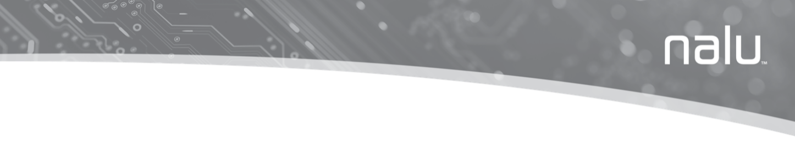

Nalu™ neurostimulation system
user instructions for use

Explanation of Symbols on Product or Package
Refer to the appropriate product for symbols that apply.
Symbol | Title | Explanation | Standard | Reference
 | Manufacturer | Medical device manufacturer | ISO 15223-1 | 5.1.1
 | Date of manufacture | Date when the medical device was manufactured. | ISO 15223-1 | 5.1.3
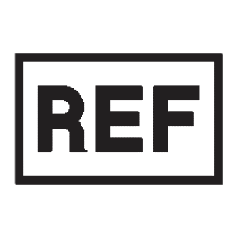 | Catalogue number | Manufacturer’s catalogue number so that the medical device can be identified. | ISO 15223-1 | 5.1.6
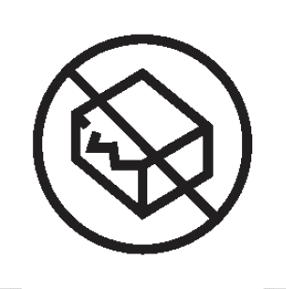 | Do not use if package is damaged | Medical device should not be used if the package has been damaged or opened. | ISO 15223-1 | 5.2.8
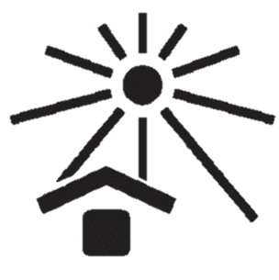 | Keep away from sunlight | A medical device that needs protection from light sources. | ISO 15223-1 | 5.3.2
 | Keep dry | A medical device that needs to be protected from moisture. | ISO 15223-1 | 5.3.4
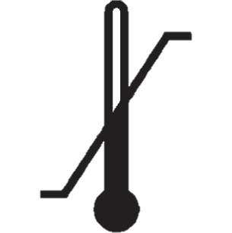 | Temperature limit | The temperature limits to which the medical device can be safely exposed. | ISO 15223-1 | 5.3.7
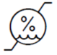 | Humidity limitation | Indicates the range of humidity to which the device can be safely exposed | ISO 15223-1 | 5.3.8
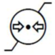 | Atmospheric pressure limitation | Indicates the range of atmospheric pressure to which the device can be safely exposed | ISO 15223-1 | 5.3.9
 | Consult instructions for use | Indicates the need for the user to consult the instructions for use. | ISO 15223-1 | 5.4.3
 | Refer to instruction manual/booklet. | Indicates the instruction manual/booklet must be read. (This symbol is blue and white on the device label) | ISO 7010:2011 | M002
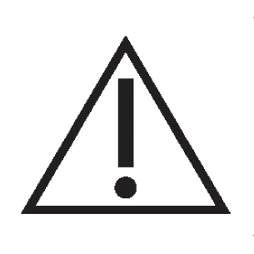 | Caution | User to consult the instructions for use for important cautionary information such as warnings and precautions that cannot, for a variety of reasons, be presented on the medical device itself. | ISO 15223-1 | 5.4.4
 | Medical Device | Indicates the item is a medical device | ISO 15223-1 | 5.7.7
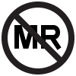 | MR Unsafe | Medical device poses unacceptable risks to the patient, medical staff or other persons within the MR environment. | ASTM F2503-13 | Fig. 9
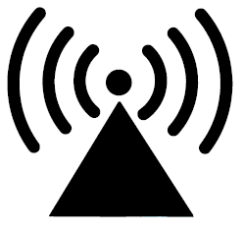 | Radio Transmitter | Device contains a radio-frequency (RF) transmitter, which may cause RF interference with other devices near this device | IEC 60601-1-2:2007 | 5.1.1
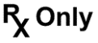 | Prescription use only | Caution: Law prohibits dispensing without prescription | 21 CFR 801.109 | N/A
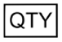 | Quantity | Indicates the total number of products provided in a package. | N/A | N/A
 | Serial Number | Manufacturer’s serial number so that a specific medical device can be identified. | ISO 15223-1 | 5.1.7
 | Protected against electric shock | Device contains a type BF applied part to protect you from shock. The device is internally powered and is intended for continuous operation | IEC 60417 | 5333
IP68 | Protected from dust and immersion in water | Protected from dust and against effects of immersion in water up to 1.5m depth for 30 minutes occasionally | IEC 60529 | N/A
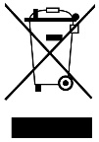 | Do not throw in the trash | This product shall not be treated as household waste. Instead it is the user’s responsibility to return this product to Nalu Medical for reprocessing.  By ensuring that this product is disposed of properly, you will help prevent potential negative consequences for the environment and human health, which could be caused by inappropriate waste handling of this product. The recycling of materials will help to conserve natural resources.  For more information about how to return this product for recycling, please contact Nalu Medical. | BS EN 50419 Marking of Electrical and Electronic Equipment in Accordance with Article 11(2) of Directive 2002/96/EC (WEEE) | Fig. 1

Table of Contents
Introduction 10
Indications for Use 10
Permanently Implanted System Description 10
Implantable Pulse Generator 11
Leads 11
Therapy Disc 11
Trial System Description 11
Leads 11
Trial Therapy Disc 11
Lead Extension 12
Electrode Interfacing Cable 12
System Accessories 12
Adhesive Clip 12
Relief Belt 12
Limb Cuff 12
Remote Control 12
Base Station Charger 12
Safety Information 12
Contraindications 12
Warnings 13
Precautions 20
Adverse Event Summary 24
Therapy Disc 27
Description 27
Therapy Disc Features 27
Powering ON the Therapy Disc 28
Powering ON the Trial Therapy Disc (For the Trial System Only) 29
Connecting the Therapy Disc with the Nalu Implantable Pulse Generator 30
Connecting the Trial Therapy Disc (For the Trial System Only) 31
Increasing Stimulation from the Trial Therapy Disc 31
Decreasing Stimulation from the Trial Therapy Disc 31
Changing the Stimulation Program from the Trial Therapy Disc 31
Low Battery Mode on the Therapy Disc 32
Low Battery Mode on the Trial Therapy Disc (For the Trial System Only) 32
Powering OFF the Therapy Disc 33
Powering OFF the Trial Therapy Disc (For the Trial System Only) 33
Adhesive Clip 36
Description 36
Preparing Your Skin 36
Applying the Clip 37
Removing Therapy Disc 38
Adhesive Wear Time 38
Removing the Clip 38
Relief Belt 39
Description 39
Placing the Therapy Disc in the Relief Belt Bumper 39
Removing the Therapy Disc from the Relief Belt Pocket 40
Wearing the Relief Belt 40
Removing the Relief Belt 40
Relief Belt Care 40
LIMB CUFF INSTRUCTIONS FOR USE 41
Limb Cuff Care 41
Thigh wrap INSTRUCTIONS FOR USE 42
Thigh Wrap Care 42
Base Station Charger 43
Description 43
Powering Up the Charger 43
Charging the Therapy Disc 44
Charging the Therapy Disc (For Trial System Only) 44
Removing the Therapy Disc 44
Powering Down the Charger 45
Troubleshooting 46
Safety and Technical Checks 48
Cleaning Your Device 48
Cleaning the Therapy Disc 48
Cleaning the Trial Therapy Disc 48
Therapy Disc, Charger, and Clip Disposal 49
Environmental Conditions for Storage and Operation 49
Therapy Disc 49
Therapy Disc Charger 49
Adhesive Clip 49
Identification Card 50
When to Call Your Clinician 50
Kit Contents 51
Device Specifications 53
Radiofrequency (RF) and Wireless Data Parameters 57
Quality of Service for Wireless Technology 58
Troubleshooting for Wireless and Coexistence Issues 59
Statement of FCC Compliance (FCC ID: 2AMB3-34001-001, FCC ID: 2AMB3-BSC) 60
RF Exposure Statement (FCC ID: 2AMB3-BSC) 61
Cybersecurity 65
Contact Information 66

Introduction
This user manual gives detailed instructions on how to use your Nalu™ Neurostimulation System. It includes instructions for both the Permanently Implanted System and the Trial System.

Indications for Use
Spinal Cord Stimulation (SCS)
This system is indicated as the sole mitigating agent, or as an adjunct to other modes of therapy used in a multidisciplinary approach for chronic, intractable pain of the trunk and/or limbs, including unilateral or bilateral pain.
The trial devices are solely used for trial stimulation (no longer than 30 days) to determine efficacy before recommendation for a permanent (long term) device.
Peripheral Nerve Stimulation (PNS)
This system is indicated for pain management in adults who have severe intractable chronic pain of peripheral nerve origin, as the sole mitigating agent, or as an adjunct to other modes of therapy used in a multidisciplinary approach. The Nalu Neurostimulation System for PNS is not intended to treat pain in the craniofacial region.
The trial devices are solely used for trial stimulation (no longer than 30 days) to determine efficacy before recommendation for a permanent (long term) device.

Permanently Implanted System Description
The Permanently Implanted Nalu Neurostimulation System is comprised of wirelessly powered Implantable Pulse Generator, lead(s), anchor(s) and a Therapy Disc. The Nalu Implantable Pulse Generator and lead(s) are designed to be implanted and configured by qualified medical professionals. The Therapy Disc is designed to be worn when stimulation is needed. Stimulation programs can be selected and adjusted from the Therapy Disc (trial system only) or a remote-control application.
A Nalu Neurostimulation System Clinician Programmer is used by your clinician or a Nalu representative under a clinician’s guidance to set up your stimulator and make adjustments later if needed.

Implantable Pulse Generator
The Nalu Implantable Pulse Generator is the implanted battery-free, microstimulator that receives power and stimulation commands from the Therapy Disc. The service life of the Implantable Pulse Generator is 18 years.

Leads
Leads are surgical wires that connect to the Nalu Implantable Pulse Generator and transfer stimulation from the implanted pulse generator to the target location.

Therapy Disc
The Therapy Disc is the externally worn transmitter module that powers and sends stimulation commands to the Nalu Implantable Pulse Generator. The Therapy Disc is positioned externally over the implant using an adhesive retention clip or textile belt and may be controlled using integrated buttons (trial system only) or via the Nalu Remote Control application. The service life is 3 years for the Therapy Disc and Charger and 1 year for the Trial Therapy Disc.
The term “Therapy Disc” is applicable to both the Trial Therapy Disc and the Therapy Disc unless otherwise indicated in this document.

Trial System Description
The Trial Nalu Neurostimulation System is comprised of implanted leads, lead extensions, Electrode Interfacing Cable and extension, and a Trial Therapy Disc for a trial period. The trial period is used to determine whether spinal cord stimulation or peripheral nerve stimulation, and the Nalu Neurostimulation System are appropriate for you.

Leads
Leads are surgical wires that transfer stimulation from the Trial Therapy Disc to the target location.

Trial Therapy Disc
The Trial Therapy Disc powers and sends signals to the implanted leads during the trial period.

Lead Extension
The lead extension adds additional length to a lead to connect to the Electrode Interfacing Cable, as needed, for connection to the Trial Therapy Disc.

Electrode Interfacing Cable
The Electrode Interfacing Cable connects the leads or the lead extensions with the Trial Therapy Disc during the user’s Nalu Neurostimulation System trial period.

System Accessories

Adhesive Clip
The adhesive clip holds the Therapy Disc in place over the Implantable Pulse Generator location.

Relief Belt
The relief belt holds the Therapy Disc in place over the Implantable Pulse Generator location.

Limb Cuff
The limb cuff holds the Therapy Disc in place over the Implantable Pulse Generator location.

Remote Control
The Nalu Remote Control Application is an application that runs on Android and IOS platforms and can be optionally used to control and manage Therapy Discs over a secure Bluetooth® Low Energy connection.

Base Station Charger
The Nalu charger recharges the batteries inside both the Therapy Discs. Charger Wall Adapter provides power to the Base Station Charger.

Safety Information

Contraindications
Users contraindicated for this therapy are those who:
- Are unable to operate the system
- Have failed trial stimulation by failing to receive effective pain relief
- Are poor surgical risks
- Are pregnant
Exposure to shortwave, microwave, or ultrasound diathermy – Diathermy should not be operated within the vicinity of a patient implanted with a Nalu Neurostimulation System or when wearing a Therapy Disc. The energy from diathermy can be transferred through the stimulator and cause tissue damage, resulting in severe injury.
Occupational exposure to high levels of non-ionizing radiation that may interfere with therapy – Patients who regularly work in environments with elevated levels of non-ionizing radiation should not be implanted with the device. The energy in high-level areas can be transferred through the device and cause tissue damage, resulting in severe injury. Examples of environments having high level non-ionizing radiation include the following:
- Radio or cell phone transmission stations
- Facilities using radiofrequency heat sealers or induction heaters
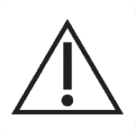
- Electric power infrastructure-controlled environments (i.e. step-down transformers or high voltage power lines)

Warnings

Implanted Cardiac or Other Neurostimulation Systems – Patients who have implanted cardiac or other neurostimulation systems should not use the Nalu Neurostimulation System. Electrical pulses from the Nalu Neurostimulation System may interact with the sensing operation of an implanted cardiac or neurostimulation system, causing the system to respond inappropriately.
Electromagnetic Interference (EMI) – EMI is a field of energy generated by equipment found in the home, work, medical, or public environments. Very strong EMI can interfere with the System. The device includes features that provide protection from EMI. Most electrical devices and magnets encountered in a normal day will not affect the operation of the System; however, strong sources of EMI could result in the following:
- Serious user injury resulting from heating of the implanted device and damage to surrounding tissue.
- System damage resulting in a loss of, or change in, symptom control that might require additional surgery.
- Operational changes to the Therapy Disc. This may cause the external device to turn on, turn off, or reset to factory settings. If this occurs, the Therapy Disc needs to be reprogrammed.
- Unexpected changes in stimulation, causing a momentary increase in stimulation or intermittent stimulation. Some users have described a jolting or shocking sensation. Although the unexpected change in stimulation may feel uncomfortable, it will not damage the device or cause direct injury to the user. In rare cases, as a result of the unexpected changes in stimulation, users have fallen down and been injured.
If you suspect that your Nalu Neurostimulation System is being affected by EMI, then you should:
- For the Therapy Disc – Remove
- For the Trial Therapy Disc – Disconnect and/or Turn Off Stimulation
- Immediately move away from the equipment or object.
Note: ‘Harmful Interference’ is defined in 47 CFR § 2.1 by the FCC as follows. Interference which endangers the functioning of a radionavigation service or of other safety services or seriously degrades, obstructs, or repeatedly interrupts a radio communication service operating in accordance with the [ITU] Radio Regulations.
Electromagnetic Equipment/ Environments—Avoidance of high electromagnetic equipment radiators or environments is highly encouraged. Examples of equipment and/or environments include the following:
- High-power amateur transmitters/antennas or citizen band (CB) radio or Ham radio used for private recreation, communication, and wireless experimentation.
- Electric arc welding or resistance welding equipment used for melting and joining metals or plastics.
- Industrial electric induction furnace/heater or electric arc furnace/heater used for melting metals and plastics.
- High-voltage areas identified by fenced areas, restricted access signs, and caution signs (safe if outside the fenced area).
- Microwave transmitters identified by fenced areas, restricted access signs, and caution signs (safe if outside the fenced area).
- Television, cell phone and radio towers identified by fenced areas, restricted access signs, and caution signs (safe if outside the fenced area).
- Linear power amplifiers used for increasing the power output of radio transmitters, wireless communication applications, audio equipment or other electronic equipment.
- Radio telemetry equipment used for tracking location of vehicles, equipment or animals.
- Tag deactivators used in retail/commercial security systems.
Use of accessories, transducers and cables other than those specified or provided by the manufacturer of this equipment could result in increased electromagnetic emissions or decreased electromagnetic immunity of this equipment and result in improper operation.
Portable RF communications equipment (including peripherals such as antenna cables and external antennas) should be used no closer than 30 cm (12 inches) to any part of the Nalu Neurostimulation System. Otherwise, performance degradation of the equipment might occur.
Magnets and Magnetic Fields – Direct / close contact of the Therapy Disc to commercial or household magnets, including those found in electronic devices (such as cellular phones and tablets), could result in permanent damage to the Therapy Disc. Strong magnetic fields generated from electromagnetics (such as motors, machinery, and Tag Deactivators) could also result in permanent damage to the Therapy Disc.
Machinery or Heavy Equipment – Machinery and heavy equipment (including vehicles) should not be operated while using the Nalu Neurostimulation System. Malfunction of the System could result in the loss of body control, body function, or a feeling that could render the user incapable of controlling the equipment.
Theft Detectors and Metal Screening Devices – Certain types of antitheft devices, such as those used at the entrances/exits of department stores, libraries, and other public establishments, and/or airport security screening devices may affect stimulation. If you are sensitive to low stimulation thresholds, you may experience a momentary increase in perceived stimulation, which has been described as “uncomfortable” or “jolting”. Use caution when approaching such a device and request assistance to bypass the device. If you must proceed through the device, remove the Therapy Disc and proceed with caution, but be sure to move through the detector quickly.
Temperature Rise During Stimulation – During prolonged use of Therapy Disc the temperature of the device may rise by 1°C above ambient temperature. If the Therapy Disc becomes uncomfortable remove the device from the clip and discontinue use.
When you are considering additional medical tests or treatments, please share the following Warnings with your clinician.
Active Implantable or Body-Worn Medical Devices – Safety has not been established for users who use the Nalu Neurostimulation System with other active implantable or body-worn medical devices. Malfunction and/or damage could occur to either system that could result in harm to the user or other people nearby
Magnetic Resonance Imaging (MRI)—MR Unsafe – For the Nalu Neurostimulation System, the only components that are allowed into the MRI system room are the Leads (Model 12001-040, 12005-025, 12005-040, 12010-040), the Nalu Anchor (Model 13001), and the Nalu Implantable Pulse Generators (Model 11003-002, 11004-002, 11006-002, 11007-002, 11009-002).
All other components (i.e., the external component and programmer) are MR Unsafe and not permitted in the MRI system room.
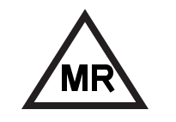
Magnetic resonance imaging (MRI) – MR Conditional – Prior to conducting or recommending an MRI examination on a patient with the Nalu Neurostimulation System, it is important to read and understand the entire manual MA-000105 entitled, “MAGNETIC RESONANCE IMAGING (MRI) SAFETY INFORMATION”, which pertains to performing an MRI examination safely in a patient.
These instructions apply only to the Nalu Neurostimulation System and do not apply to other products. If you have any questions, please contact Nalu Medical or visit Nalu’s website <www.nalumed.com>.
The only Nalu Medical components that are labeled and approved as MR Conditional are the Leads (Model 12001-040, 12005-025, 12005-040, 12010-040), the Nalu Anchor (Model 13001) and the Nalu Implantable Pulse Generators (Model 11003-002, 11004-002, 11006-002, 11007-002, 11009-002). All other components are MR Unsafe.
Computed Tomography (CT) Scanning – Safety has not been established for CT scanning of users with a Nalu Neurostimulation System. X-rays from the scan could cause unintended shocks or malfunctions of the System and may not be immediately detectable.
- The CT operator should use CT scout views to determine if implanted medical devices are present and their location relative to the programmed scan range. For CT procedures in which the device is in or immediately adjacent to the programmed scan range, the operator should:
- Remove the Therapy Disc from the CT scan range.
- Minimize X-ray exposure to the implanted device by:
- Using the lowest possible X-ray tube current consistent with obtaining the required image quality.
- Making sure that the X-ray beam is not placed over the Nalu Implantable Pulse Generator for more than a few seconds.
- After CT scanning directly over the implanted device:
- Place the Therapy Disc on body/connect the Trial Therapy Disc and turn on stimulation.
- Check for proper stimulation, and that indicator lights are operating as expected.
- Remove the Therapy Disc if it is suspected that the device is not functioning properly.
Radiofrequency (RF) Ablation – Safety has not been established for RF ablation in users with the device. RF ablation may result in heating and tissue damage. Do not use RF ablation anywhere near the device. If RF ablation is used, ensure that ablation is not performed over or near the device.
Medical Devices/Therapies – The following medical therapies or procedures may turn stimulation off or may cause permanent damage to the Nalu Implantable Pulse Generator particularly if used in close proximity to the device:
- Lithotripsy
- Electrocautery. Do not use monopolar cautery
- External defibrillation
- Radiation therapy
- Ultrasonic scanning
- High-output ultrasound
- Bone growth stimulators
- Dental Drills and Ultrasonic Probes
- Electrolysis
- Laser Procedures
- Radiation Therapy
- TENS (transcutaneous electrical nerve stimulation)

If the user is required by medical necessity to undergo any of the above therapies or procedures, the procedural guidelines below must be followed. Ultimately, however, the device may need to be explanted as a result of associated failure.

- Turn off stimulation of the Nalu Implantable Pulse Generator before the procedure or therapy.
- All equipment, including ground plates and paddles, must be used as far away from the Implantable Pulse Generator as possible.
- Bipolar electrocautery is recommended. Do not use monopolar electrocautery.
- Every effort should be taken to keep fields, including current, radiation, or high-output ultrasonic beams, away from the Implantable Pulse Generator.
- If radiation therapy is required, the area over the Nalu Implantable Pulse Generator should be shielded with Lead.
- Equipment should be set to the lowest energy setting clinically indicated.
- Instruct users to confirm Implantable Pulse Generator functionality following treatment by turning on the Implantable Pulse Generator and gradually increasing stimulation to the desired level.
- Damage from these procedures to the Nalu Neurostimulation System may not be detected immediately.
Psychotherapeutic Procedures – Safety has not been established for psychotherapeutic procedures using equipment that generates electromagnetic interference (e.g., electroconvulsive therapy, transcranial magnetic stimulation) in users who have spinal cord stimulators. Induced electrical currents can cause heating that may result in tissue damage.
Other Medical Procedures – EMI from the following medical procedures is unlikely to affect the device:
- Diagnostic x-rays or fluoroscopy
- Magnetoencephalography (MEG)
- Positron emission tomography (PET) scans
- Therapeutic magnets (e.g., magnetic mattresses, blankets, wrist wraps, elbow wraps)
Painful Stimulation – If the user experiences painful stimulation do the following:
For Therapy Disc – Remove or decrease the stimulation amplitude
For Trial Therapy Disc – Disconnect or decrease the stimulation amplitude
Contact your clinician if this continues to occur.
Strangulation – Entanglement in the Therapy Disc Charger cable, Electrode Interfacing Cable, or Relief Belt may cause a fall or strangulation.
Tampering – Do not modify or tamper with any component of the Nalu Neurostimulation System. Tampering with the device could result in harm. If the device is not working properly, contact your clinician for help.

Precautions
Clinician Training – If you have a Nalu Neurostimulation System, please inform your regular clinician or specialist.
Your clinician should visit www.nalumed.com for more information about the system prior to any medical procedures.
Clinician Instructions – Always follow the programs and therapy instructions established by your clinician. Failure to do so may cause the therapy to be less effective in providing pain relief.
Post-Operative – During the two weeks following surgery, it is important to use extreme care so that appropriate healing will secure the implanted components and close the surgical incisions:
- Do not lift objects of more than five pounds.
- Do not engage in rigorous physical activity such as twisting, bending, or climbing.
- If new Leads were implanted, do not raise your arms above your head.
Temporarily, there may be some pain in the area of the implant as the incisions heal. If discomfort continues beyond two (2) weeks, contact your clinician.
If you notice excessive redness around the wound areas during this time, contact your clinician to check for infection and administer proper treatment. In rare cases, adverse tissue reaction to implanted materials can occur during this period.
Be sure to consult your clinician before making lifestyle changes due to decreases in pain.
Medical Tests and Procedures – Before undergoing medical tests or procedures, contact your clinician to determine if the procedure will cause damage to the user or to the System.
When you are considering additional medical treatments, please share the following Precautions with your clinician.
The following precautions should be followed to properly use and care for your Therapy Disc and/or Trial Therapy Disc:
Use the Therapy Disc as Directed – Use the Therapy Disc only as explained your clinician or as discussed in the User Manual. Using the Therapy Disc in any other manner could result in harm. Do not use any equipment or accessories that are not supplied with the Therapy Disc.
Use of Another User’s Therapy Disc – Use of another user’s Therapy Disc will not deliver therapy. The therapy programmed is a unique prescription for each user and their specific Nalu Implantable Pulse Generator.
Handle the Therapy Disc with Care – The Therapy Disc is a sensitive electronic device. Avoid dropping the device onto hard surfaces. Keep the Therapy Disc out of the reach of children, pests and pets.
Keep the Trial Therapy Disc Dry – The Trial Therapy Disc is not waterproof. Keep the Trial Therapy Disc dry to avoid damage.
Avoid extended immersion with the Therapy Disc – The Therapy Disc can get wet within certain limits. It is not recommended that the Therapy Disc be used during water activities. Upon shipment, the Therapy Disc is rated IP68 (protected from total dust ingress, protected from immersion between 15 centimeters and 1.5 meters in depth for up to 30 minutes) and over time with normal wear and use, the Therapy Disc may become more susceptible to damage by immersion.
Clean the Therapy Disc – When needed, clean the outside of the Therapy Disc with a damp cloth to prevent dust and dirt.
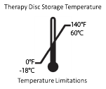
Storage Temperatures – The Nalu Neurostimulation System should be kept within the storage temperatures listed on product packaging. Exceeding the storage temperature can affect the performance of the device.
Random Component Failure – Although unlikely, a failure of the Nalu Neurostimulation System is possible due to random component failure. If any part of your Neurostimulation System stops working or changes how it works, remove the Therapy Disc and contact your Nalu representative.
Unexpected Changes in Stimulation – Electromagnetic interference, changes in posture, and other activities can cause a perceived increase in stimulation. Some users have described this as a jolting or shocking sensation. Before engaging in potentially unsafe activities, you should do the following:
- For Therapy Disc – Remove
- For Trial Therapy Disc – Disconnect and/or Turn Off Stimulation
Discuss these activities with your clinician.
Airline Policies – Follow airline policies for use of medical spinal cord stimulation systems and electronic equipment during flights. Defer all questions to airline personnel. Carry your ID card with you at all times.
Flammable or Explosive Environments – Do not use the Therapy Disc in flammable or explosive environments. Using the Therapy Disc in one (1) of these environments could result in harm.
Activities Requiring Excessive Twisting or Stretching – Avoid activities that could potentially put stress on the device. Activities that include sudden, excessive, or repetitive bending, twisting, bouncing, or stretching can cause your stimulator to fracture or migrate. This can result in a loss of stimulation, intermittent stimulation, and additional medical procedures.
Scuba Diving or Hyperbaric Chambers – Do not dive below 13 meters (45 feet) of water or enter hyperbaric chambers above 1.48 atmospheres absolute (ATA) with the Nalu Implantable Pulse Generator. These conditions can damage the device. Before diving or using a hyperbaric chamber, discuss the effects of high pressure with the clinician. Do not dive or enter hyperbaric chambers with the Therapy Disc.
Remote Control Interference – If interference is suspected during use of the remote control, confirm that the Bluetooth data transmission is operating properly. If the Nalu Remote Control application is not connecting to the Therapy Disc:
- Terminate the current stimulation program and shut down the Nalu Remote Control application.
- Check for sources of Bluetooth interference in the surrounding area.
- Remove or turn off the source of interference.
- Re-establish the Bluetooth link with the Therapy Disc through pairing.
Reopen the Nalu Remote Control application and resume the therapy.
Adverse Environments – Any user with a Nalu Neurostimulation System should seek medical guidance before entering environments which could adversely affect the operation of the Nalu Neurostimulation System, including areas protected by a warning against entry by users.

Adverse Event Summary
Below is a list of side effects that may occur during surgery and/or during standard spinal cord stimulation:
- Undesirable changes in stimulation sensation and/or location with or without user movement.
- Persistent post-surgical pain at hardware implantation sites.
- Seroma or hematoma at surgery sites.
- Spinal cord injury and or compression with subsequent neurological deficits - permanent or temporary.
- Stroke.
- Lead migration, causing the electrodes to move from the intended location.
- Implantable Pulse Generator migration, which may or may not require surgical intervention.
- Fracture of the lead(s) or failure of other system components, which may result in the loss of stimulation or untoward stimulation induced dysesthesias.
- Allergic or rejection reaction to the anesthesia, implanted components, or external components.
- Reaction to the selected antibiotics or to the Nalu device including: rash, diarrhea, abdominal pain, nausea/vomiting, dizziness, headaches, hypersensitivity (allergic) reactions
- Undesirable skin problems such as infection, irritation, blistering, tearing or allergic reactions that may occur during the use of any wearable component of the Nalu Neurostimulation System.
- Skin irritation, including redness, itchiness, and bumpiness
- Infection at implant site that may or may not require hospitalization and require treatment with antibiotic therapy or surgical intervention
- Cerebral spinal fluid (CSF) leak inclusive of those requiring active medical intervention.
- Inadequate pain relief or increase in pain following system implantation
- Wound complications that may require medical intervention inclusive of surgical management.
- Thromboembolic events requiring medical intervention; inclusive of deep vein thrombosis and pulmonary embolism.
- Death and/or catastrophic neurological complications.
- Anesthetic complications - e.g. nausea, urinary retention.
- Headache.
- Bleeding.
- Excessive fibrotic reaction to device leading to pain and/or new pain symptoms.
- Unexpected stimulation effects including but not limited to: chest wall stimulation, muscle stimulation, tremor, dyskinesia, superficial pain, cramping, light-headedness and metallic taste.
- Weakness.
- Numbness.
- Clumsiness.
- Tissue damage.
- Nerve damage.
- Paralysis.
- Swelling.
- Sensory loss.
- Discomfort during the treatment.
- Skin erosion around the Nalu Implantable system or at the site of the Nalu wearable devices.
- Battery failure
- Lead breakage requiring replacement of the Lead.
- Electromagnetic interference causing a change in System performance.
- Loss of therapeutic effect despite a functioning system.
- Hardware malfunction requiring replacement of the neurostimulator components.
- Pain from a non-injurious stimulus to the skin (allodynia).
- An exaggerated sense of pain (hyperesthesia).
- Change in stimulation that are possibly related to tissue changes around the electrodes, shifts in electrode position, loose electrical connections, and lead or extension fractures which have been described by some users as uncomfortable stimulation (a jolting or shocking sensation).
- Formation of reactive tissue in the epidural space around the lead can result in delayed spinal cord compression and paralysis, requiring surgical intervention. Time to onset can range from days to many years after implant.
- Arrhythmia.
- Cardiac arrest.
- Intracranial hypotension.
- Fracture of the lead(s) or failure of other system components.
- Loss of therapy or unpleasant paresthesia.
Adverse effects of stimulation are usually mild and go away when stimulation is turned off. Contact your clinician immediately if you experience any problems. There may be changes in the level of pain control over time.
Notice: In the event of any serious incident that has occurred in relation to the Nalu Neurostimulation System, the user should report the incident to Nalu Medical at +1.800.618.3402 or visit www.nalumed.com.

Therapy Disc

Description
The Therapy Disc is a part of the Nalu Neurostimulation System that wirelessly powers and sends stimulation commands to the Nalu Implantable Pulse Generator. The Therapy Disc is positioned over the implant using an Adhesive Retention Clip or Relief Belt/ Limb Cuff and may be controlled using integrated buttons (trial system only) or via a remote-control application (see Nalu Remote Control Application Instructions for Use for details). Battery life is optimal when the Therapy Disc is placed directly over the implant. You are provided with two (2) Therapy Discs in the initial Nalu User’s Kit, one to be used while the other is charging.
The Trial Therapy Disc has a wired connection to the lead or lead extension to provide stimulation during the trial period.

Therapy Disc Features
Therapy Disc

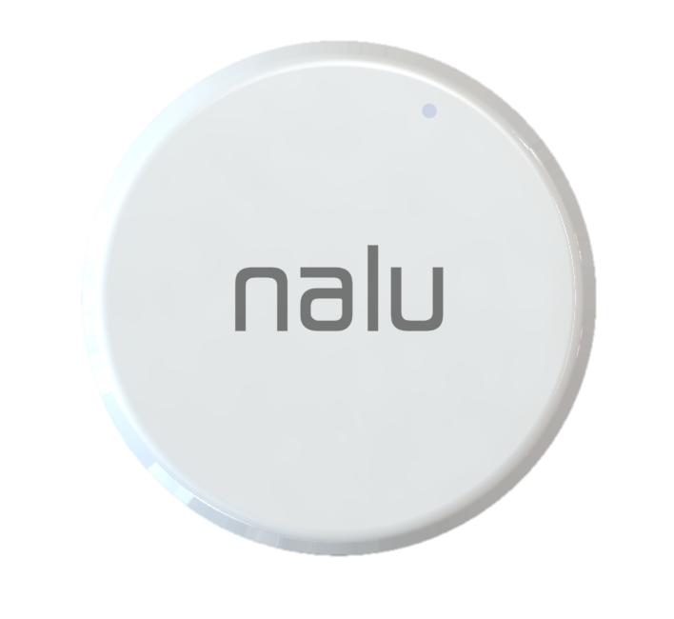
LED (white, blue, green, orange)
- Indicates Therapy Disc status
Buzzer (Vibration)
- Indicates Therapy Disc status

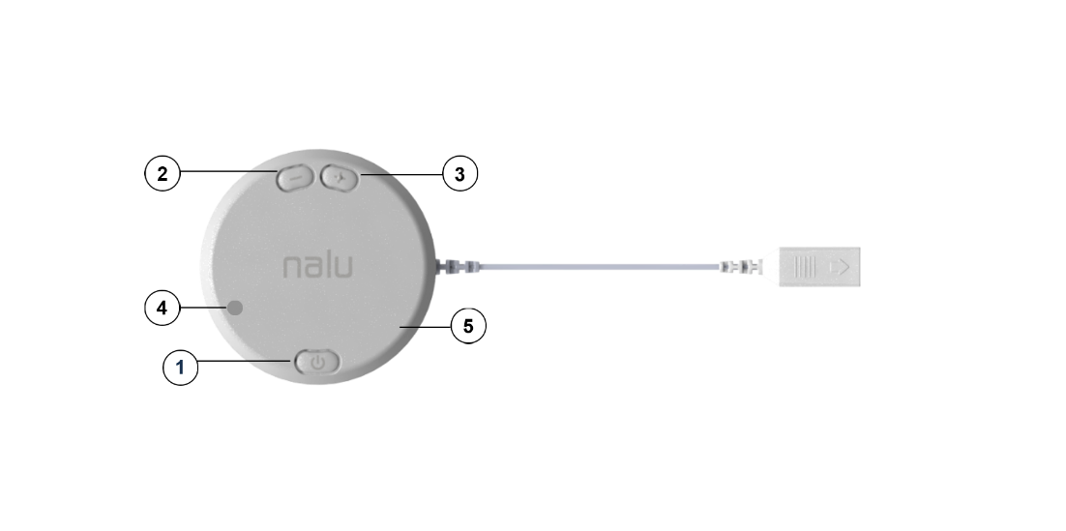
5. Trial Therapy Disc
2. Down Button
- Decrease Stimulation
- Dismisses and reactivates alerts
Micro HDMI
Connector
- ON/OFF Program
- Turns Therapy Disc on/off
- Changes stimulation programs
4. LED
3. Up Button
- Increase Stimulation

Powering ON the Therapy Disc
- If not already in the charger, place the disc in the charger momentarily, once it blinks and buzzes remove the Therapy Disc from the Base Station Charger.
- Listen, watch, and feel.
- The buzzer will beep and vibrate, and the white LED will blink to indicate battery level.
# White Blinks / Beeps | Battery Level
4 | Fully charged
3 | ¾ charged
2 | ½ charged
1 | ¼ charged
Orange | Discharged (low battery mode)

- Following the white LED blinks, the green LED will blink to indicate the most recently used program. The number of green LED blinks corresponds to the current program. A single long green LED blink indicates that the current “program” is the Schedule mode, which cycles through scheduled programs configured by the clinician.
NOTE: A Schedule can consist of stimulation programs and Idle programs. An Idle program is essentially a period of no stimulation.

Powering ON the Trial Therapy Disc (For the Trial System Only)
- Press and release the ON / OFF Program button.
- Listen and watch.
- The buzzer will beep and the white LED will blink to indicate battery level.
# White Blinks / Beeps | Battery Level
4 | Fully charged
3 | ¾ charged
2 | ½ charged
1 | ¼ charged
Orange | Discharged (low battery mode)

- Following the white LED blinks, the green LED will blink to indicate the most recently used program. The number of green LED blinks corresponds to the current program. A single long green LED blink indicates that the current “program” is the Schedule mode, which cycles through scheduled programs configured by the clinician.
NOTE: A Schedule can consist of stimulation programs and Idle programs. An Idle program is essentially a period of no stimulation.

Connecting the Therapy Disc with the Nalu Implantable Pulse Generator
- Place the Therapy Disc over the implant.
- Three (3) short beeps will sound, and the buzzer will vibrate when the Therapy Disc connects to the implant.
NOTE: The Therapy Disc starts stimulation at the most recently used program and stimulation level.
NOTE: If the Therapy Disc becomes disconnected from the implanted Pulse Generator after having been connected, the Therapy Disc will beep and vibrate once every second.
NOTE: Alerts for the Therapy Disc can be configured using the Remote Control Application.

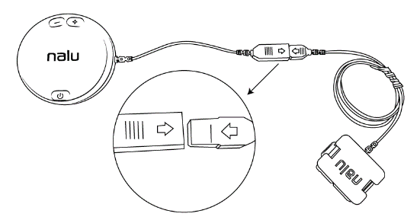
Connecting the Trial Therapy Disc (For the Trial System Only)
Figure 1: Connect Trial Therapy Disc to Electrode Interfacing Cable
- Plug the micro-HDMI adapter into the micro-HDMI port on the Trial Therapy Disc as shown in Figure 1.
- Three (3) short beeps will sound when the Trial Therapy Disc connects to the lead.

Increasing Stimulation from the Trial Therapy Disc
- Press and release the Up button.
- The green LED will blink after each button press.
Maximum Stimulation: When at the maximum level of stimulation, further attempts to increase stimulation will cause the buzzer to beep twice and the orange LED to blink twice.

Decreasing Stimulation from the Trial Therapy Disc
- Press and release the Down button.
- The green LED will blink after each button press.
Minimum Stimulation: When at the minimum level of stimulation, further attempts to reduce stimulation will cause the buzzer to beep twice and the orange LED to blink twice.

Changing the Stimulation Program from the Trial Therapy Disc
- Press and release the ON / OFF Program button.
- The green LED will blink after the button press. The selected program will be indicated by the number of LED blinks. For example, if Program 4 is selected, the green LED will blink four (4) times.
  - If a Schedule is downloaded onto the Therapy Disc, the green LED will blink for one second when the Schedule mode is selected.
NOTE: The Therapy Disc cycles through the programs in order. When the last program is reached, the next program will be Program 1 or the schedule mode if available.
NOTE: When the Therapy Disc is cycled back to the Schedule mode, the Schedule will resume from the last executed stimulation program.
NOTE: The maximum number of programs the Therapy Disc can hold is 8.

Low Battery Mode on the Therapy Disc
- When the device is in low battery mode, the orange LED will blink slowly, and the buzzer will beep slowly seven (7) times every minute.
NOTE: Low battery mode disables stimulation and disables program change and amplitude change buttons.
NOTE: Alerts for the Therapy Disc can be configured using the Remote Control Application.

Low Battery Mode on the Trial Therapy Disc (For the Trial System Only)
- When the device is in low battery mode, the orange LED will blink slowly, and the buzzer will beep slowly seven (7) times every minute.
- To dismiss the low battery indication, press and hold the Up or Down button. The white LED will remain lit while the button is held down.
- To reactivate the low battery indication, press and hold the Up or Down button. The white LED will remain lit while the button is held down.
NOTE: Low battery mode disables stimulation and disables program change and amplitude change buttons.

Powering OFF the Therapy Disc
- The buzzer will beep and vibrate once every second when the Therapy Disc is disconnected from the implant after having been connected.
- The Therapy Disc will enter a low power state after five (5) minutes of inactivity.
NOTE: If the Therapy Disc is turned off while it is in the Schedule mode and the Schedule was running an Idle program, the Schedule will start from the stimulation program that follows that Idle program when the Disc is powered back on.

Powering OFF the Trial Therapy Disc (For the Trial System Only)
- The buzzer will beep once every second when the Therapy Disc is disconnected from the implant after having been connected.
- Press and hold the ON / OFF Program button.
- The white LED will blink while the Therapy Disc shuts down completely. The white LED will stop blinking after the Therapy Disc has powered off.
NOTE: If the Therapy Disc is turned off while it is in the Schedule mode and the Schedule was running an Idle program, the Schedule will start from the stimulation program that follows that Idle program when the Disc is powered back on.
Below is a table with button actions and the meaning of the corresponding LED or buzzer sound.
Action | LED indication | Buzzer indication | Meaning
Press ON / OFF Program Button to Power On | 4 white blinks | 4 beeps | Battery fully charged.
Press ON / OFF Program Button to Power On | 3 white blinks | 3 beeps | Battery ¾ charged.
Press ON / OFF Program Button to Power On | 2 white blinks | 2 beeps | Battery ½ charged.
Press ON / OFF Program Button to Power On | 1 white blink | 1 beep | Battery ¼ charged.
Press ON / OFF Program Button to Power On | Slow orange blinks. | 7 slow beeps per minute | Battery discharged (low battery mode).
Place Device Over Implant | N/A | 3 short beeps | Device is connected to implant.
Place Device Over Implant | N/A | 3 long beeps | Device connection failed.
Short Press on the Up Button | 1 green blink per press. | N/A | Stimulation increased.
Short Press on the Up Button | 2 short orange blinks. | 2 short beeps | Maximum stimulation level reached.
Long Press on the Up Button | N/A | N/A | Dismiss/ reactivate alert.
Short Press on the Down Button | 1 green blink per press. |  | Stimulation decreased.
Short Press on the Down Button | 2 short orange blinks. | 2 short beeps | Minimum stimulation level reached.
Long Press on the Down Button | N/A | N/A | Dismiss/ reactivate alert.
Short Press on the ON / OFF Program Button When the Device is On | (#)* green blinks | N/A | Program (#)* selected.  *(#) indicates the program number. For example, Program 3 would have three (3) green blinks.
Disc Disconnects from Internal Pulse Generator | Orange blinks every second. | Beeps every second | No communication with the implant.
Long Press on the ON / OFF Program Button to Power Off | White LED blinks for one second and then stops blinking. | N/A | Device is off.
Below is a table with Trial Therapy Disc button actions and timing.
Therapy Disc Action | Time
Short Press on Any Button | Press for less than one (1) second.
Long Press on Any Button | Press for more than one (1) second.

Therapy Disc Response | Time
Short Beeps / Blinks | Last for 0.1 seconds when the device is turned ON or OFF.
Long Beeps | Last for 0.5 seconds when the device is turned ON or OFF.
Slow Beeps / Blinks | Occur every 1.5 seconds.

Adhesive Clip
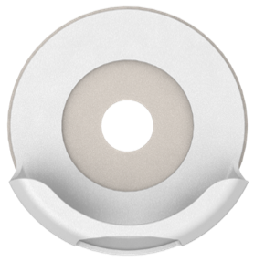  Figure 2: Clip | 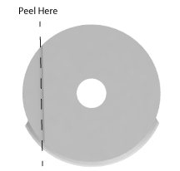  Figure 3: Clip (Back) | 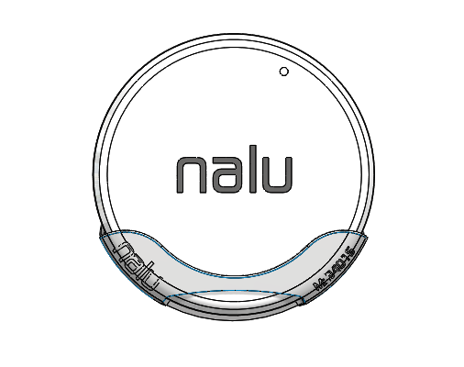  Figure 4: Clip and Therapy Disc

Description
The single-use Adhesive Clip is designed to hold the Therapy Disc on the body using a skin friendly adhesive. The Adhesive Clip is placed over the implant, and the Therapy Disc is inserted into the clip. The Adhesive Clip is not intended to be reused.
Refer to the Adhesive Clip Instructions for Use.

Preparing Your Skin
- Make sure your skin is clean and dry.
- If necessary, trim hair with scissors or small beard trimmer. Do not shave since this can lead to irritation.
- If desired, commercially available skin barrier wipes and sprays may be used to prep the skin.

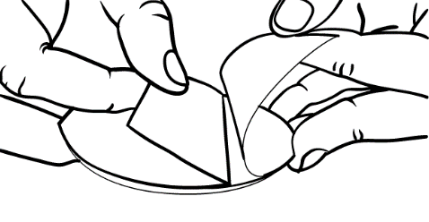
Applying the Clip
- Remove the adhesive liner, as shown in Figure 5.

Figure 5 Remove Liner
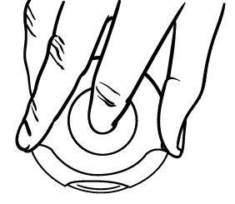
- Grasp the clip between your thumb and finger and place your index finger through the center hole. The clip should be held, as shown in Figure 6.

Figure 6 Clip Orientation
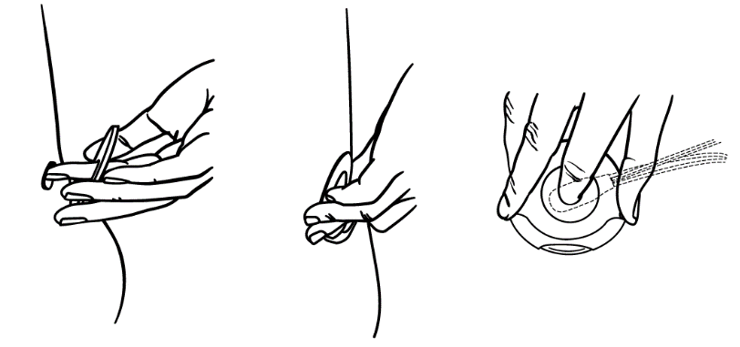
- Use your inserted index finger and locate the implant site, as shown in Figure 7.

- Once the implant site has been located, press the clip against your skin, ensuring the heel (where the therapy disc sits) is towards the bottom.
Figure 7 Locate Implant
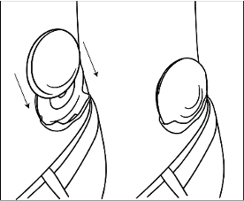
Placing the Therapy Disc into the Adhesive Clip
- Slide the Therapy Disc into the open side of the clip until it clicks into place. Ensure that “Nalu” is facing away from your skin, as shown in Figure 8.

Removing Therapy Disc
Figure 8 Load Therapy Disc
- Grip the sides of the Therapy Disc.
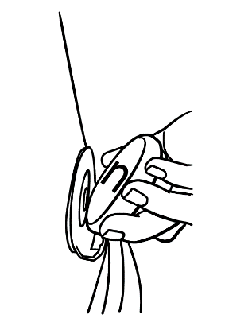
- Gently lift the Therapy Disc away from the surface of your skin and out of the clip, as shown in Figure 9.

Adhesive Wear Time
- The wear time for the Adhesive Clip varies per activity level and skin type.
- Wear the clip until it feels like it is coming loose or starts to feel uncomfortable.

Removing the Clip
Figure 9 Remove Device
- Remove the device from the clip.
- Make sure that the clip and adhesive are fully dry for easier removal.
- Using your finger, gently work between the adhesive and your skin to
loosen it before pulling it off, as shown in Figure 10.
- Hold down your skin and gently peel away the adhesive until it is fully detached as shown in Figure 11.
- Discard the used clip.
- It is recommended that any residue be cleaned using commercially available wipes and sprays designed to work with hydrocolloid adhesives. Do not use alcohol to clean the residue.
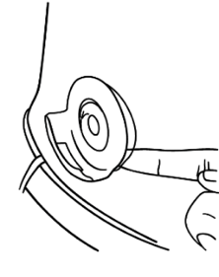  Figure 10 Remove Adhesive | 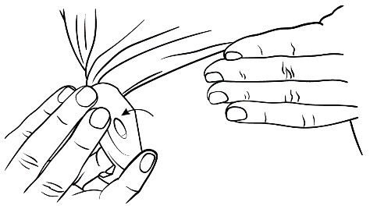  Figure 11 Remove Clip

Relief Belt

Description
The relief belt is an alternative to the adhesive clip for holding the therapy disc in place on the body. The device is inserted in the belt pocket and positioned over the implant.

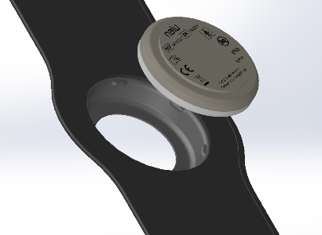
Placing the Therapy Disc in the Relief Belt Bumper
- Place Therapy Disc against the inside of the belt rubber bumper, with the white face of the disc towards the garment.
Figure12 Insert Therapy Disc
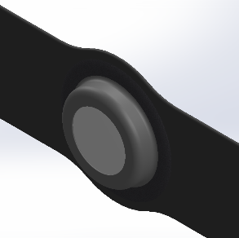
- While holding the belt in both hands, use your thumbs to firmly push the disc into the rubber bumper until it snaps into place.

Removing the Therapy Disc from the Relief Belt Pocket
- While holding the belt in both hands, use your thumbs to firmly push the white side of the disc until it pops out of the rubber, as shown in Figure 13.
Figure 13 Remove Device

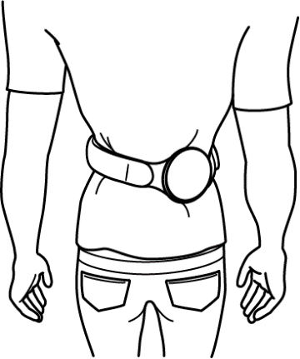
Wearing the Relief Belt
- Wear the belt over a thin layer of clothing at your waist.
- Adjust the belt tightness using the Velcro strap.
- Rotate the belt to position the device over the implant site.
NOTE: Ensure that the device connects to the implant by listening for the three (3) short beeps indicating a successful connection or check the Remote Control application.

Removing the Relief Belt
Figure 14 Wear Belt
- Undo the Velcro strap and loosen the belt.
- Remove the relief belt.

Relief Belt Care
Hand Wash. Do Not Bleach. Line Dry. Do Not Iron.

LIMB CUFF INSTRUCTIONS FOR USE
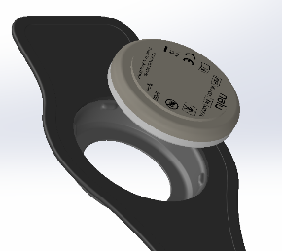
Placing the device in the limb cuff
- Place Therapy Disc against the inside of the limb cuff rubber bumper, with the white face of the disc towards the garment.
- While holding the limb cuff in both hands, use your thumbs to firmly push the disc into the rubber bumper until it snaps into place.
Figure 15 Insert Disc
Placing the limb cuff on target location
- Place the device over the implant location over a thin layer of clothing and wrap the strap around your limb.
- Place the strap through the loop and pull the strap to tighten the limb cuff.
- Secure the limb cuff in place using the Velcro tab.

Removing the limb cuff
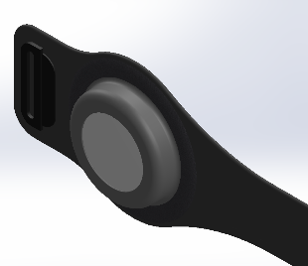
- Undo the Velcro strap and loosen the limb cuff.
- Remove the limb cuff
Removing the device from the limb cuff
- Undo the snap button.
- Pinch the device on the top and bottom and pull out of the pocket.

Limb Cuff Care
Figure 16 Remove Disc
Hand Wash. Do Not Bleach. Line Dry. Do Not Iron.

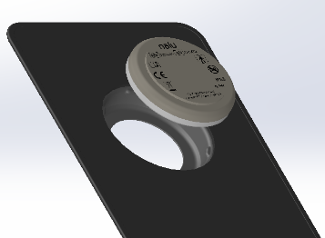
Thigh wrap INSTRUCTIONS FOR USE

Placing the device in the thigh wrap
- Place Therapy Disc against the inside of the thigh wrap rubber bumper, with the white face of the disc towards the garment.
While holding the thigh wrap in both hands, use your thumbs to firmly push the disc into the rubber bumper until it snaps into place.

Placing the thigh wrap on target location
- Place the device over the implant location over a thin layer of clothing and wrap the straps around your thigh.
Figure 17 Insert Disc
- Place each strap through each loop and pull the straps to tighten the thigh wrap. Each strap may be pulled separately to allow the garment to conform to your leg.
- Secure the thigh wrap in place using the Velcro tabs.

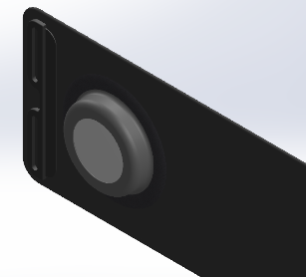
Removing the thigh wrap
- Undo the Velcro straps and loosen the thigh wrap.
- Remove the thigh wrap.

Removing the device from the thigh wrap
- While holding the thigh wrap in both hands, use your thumbs to firmly push the white side of the disc until it pops out of the rubber bumper.

Thigh Wrap Care
Figure 18 Remove Disc
Hand Wash. Do Not Bleach. Line Dry. Do Not Iron.

Base Station Charger
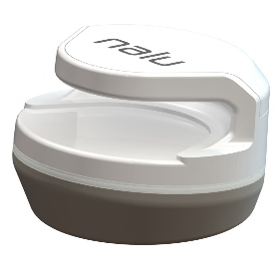
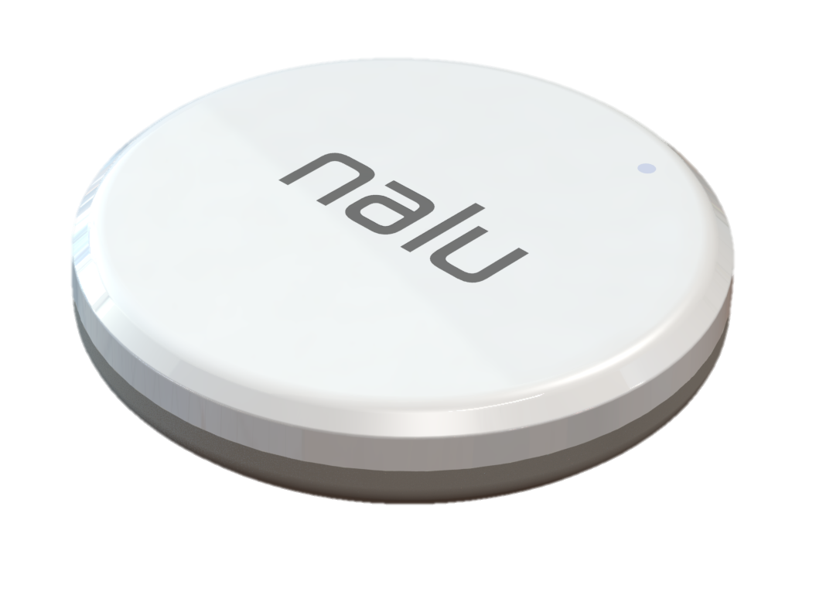

Figure 20: Base Station Charger
Figure 19: TD2 Therapy Disc

Description
The Base Station Charger charges the Therapy Disc battery. It takes approximately eight (8) hours to fully charge the Therapy Disc from full discharge. When battery is fully charged, the Therapy Disc may provide therapy from 8-40 hours (nominal 16 hours), depending on location of Therapy Disc, stimulation level, and participant use.
The battery level of the Therapy Disc can be found in the Nalu Remote Control application. The battery level is also indicated when the Therapy Disc is powered on (see Therapy Disc instructions).

Powering Up the Charger
- Only use the provided Nalu Charger Wall Adapter (Model # 43002) and USB Cable (Model # 43006). Plug the power supply into an easily accessible socket so that it is easy to disconnect when necessary.
- Connect the USB-C cable from the Power Supply to the USB terminal on the back side of the charger to provide power to the unit.
- Verify that the LED status light ring is illuminated blue, meaning that the charger is ready for use.

Charging the Therapy Disc
- Orient and slide the Therapy Disc into the charger.
- Verify that the LED status light ring changes from blue to orange (which means charging is in progress) or green (meaning that the battery is fully charged).

Note: The Therapy Disc cannot be used while charging.

Charging the Therapy Disc (For Trial System Only)
- Orient and place the Therapy Disc on the charger using the Nalu logo and Nalu ‘n’ features as guides to help with the correct placement.
- Verify that the LED status light ring changes from blue to orange (which means charging is in progress) or green (meaning that the battery is fully charged).
Note: The Therapy Disc cannot be used while charging.

Removing the Therapy Disc
- Grasp the sides of the Therapy Disc, then lift up and away from the charger base.

Powering Down the Charger
- Disconnect the USB cable from the Charger.
Device Status for Base Station Charger
LED Color | Device Status
Solid Blue | Charger ready for use
Solid Orange | Device charging / downloading data
Solid Green | Device fully charged / completed data download
Blinking Blue | Ready for use, but not cloud connected
Blinking Orange | Device error

Device Status for Charger (Trial System Only)
LED Color | Device Status
Blue | Charger ready for use
Orange | Device charging
Green | Device fully charged

Troubleshooting
Therapy Disc
Problem | Causes | Possible Actions
Uncomfortable Stimulation | The selected parameters are not suitable for your activity or posture. | Remove the Therapy Disc from your body.  Unplug the Trial Therapy Disc.  Reduce the stimulation from the Remote Control Application or the Therapy Disc.
No Stimulation | Stimulation is off. | Place Therapy Disc in Base Station Charger and remove.  Turn the Therapy Disc power OFF, then turn the power back ON (Trial System Only)
No Stimulation | Stimulation is off. | Using the remote control, turn stimulation on.
No Stimulation | The Therapy Disc is not placed over the implant. | Place the Therapy Disc directly over the implanted stimulator.
No Stimulation | The stimulation amplitude is set too low. | Increase the amplitude.
The Therapy Disc is Unresponsive | The Therapy Disc is not powered ON. | Place Therapy Disc in Base Station Charger and remove.  Turn the power ON (Trial System Only).
The Therapy Disc is Unresponsive  The Therapy Disc will not connect to the RC | The Therapy Disc functionality is frozen. | Place Therapy Disc in Base Station Charger and remove.  Turn the power OFF, then and turn it back ON (Trial System Only).
 | The battery is not charged. | Recharge the battery by placing the Therapy Disc on the charger.
 | Bluetooth® connection problem. | Restart the Remote Control application.  Restart the Therapy Disc.
The Therapy Disc Has Been Dropped | Damage to the device. | Contact your Nalu representative.
The Trial Therapy Disc becomes wet | The Trial Therapy Disc is not waterproof. | Discontinue use of the device and contact your Nalu representative.

Adhesive Clip
Problem | Causes | Possible Actions
Adhesive is Too Strong | The adhesive is not at the end of its life.  Inappropriate adhesive. | Increase the wear time of the adhesive until it gets looser.  Talk to your Nalu representative about switching to a different adhesive.
Adhesive Keeps Falling Off | Improper wear period. | Reduce your wear time. Replace the adhesive clip before it falls off.  Talk to your Nalu representative about switching to a different adhesive.
Adhesive Causing Skin Breakage | The adhesive was removed too early. | Increase your wear time and remove the adhesive when it is looser.  Adjust the next clip location to allow the damaged skin to heal.  Use the relief belt for a period of time to allow the skin to heal.  Talk to your Nalu representative about switching to a different adhesive.
Adhesive Causing Excessive Skin Irritation, Including Increased Redness, Itchiness, and Bumpiness | Possible allergic reaction. | Contact your clinician.

Safety and Technical Checks
Periodic safety checks or maintenance of the Therapy Disc are not required. The Therapy Disc contains no user-serviceable parts. If repair or service is needed, contact your clinician or a Nalu representative for a replacement. Refer to the contact information at the end of this manual.

Cleaning Your Device

Cleaning the Therapy Disc
When needed, clean the outside of the Therapy Disc with a damp cloth to prevent dirt and dust. Do not use abrasive or caustic cleaning products on your Therapy Disc.

Cleaning the Trial Therapy Disc
Clean the outside of the Trial Therapy Disc with a damp cloth when needed to prevent dirt and dust. Do not use abrasive or caustic cleaning products on your Trial Therapy Disc.

Therapy Disc, Charger, and Clip Disposal
The Therapy Disc and charger should be returned to your clinician or a Nalu representative. Do not dispose of your Therapy Disc or charger in the garbage.
For the single-use adhesive clips, adhere to local disposal requirements / regulations.

Environmental Conditions for Storage and Operation

Therapy Disc
Storage Temperature | -18°C to 60°C
Operating Temperature | 0°C to 45°C
Humidity | < 90%
Pressure | 70 kPa – 107 kPa

Therapy Disc Charger
Storage Temperature | -18°C to 60°C
Operating Temperature | 0°C to 40°C
Humidity | < 90%
Pressure | 80 kPa – 107 kPa

Adhesive Clip
Storage Temperature | 23°C
Operating Temperature | 0°C to 45°C
Humidity | < 90%
Pressure | 70 kPa – 107 kPa

Identification Card
An identification card is included in your Nalu User’s Kit. The ID card contains information about you, your stimulation system, and your doctor. Your identification card may allow you to bypass security devices. Carry this card with you at all times. If you move, change doctors, or lose your card, contact Nalu for a replacement card. Refer to the contact information at the end of this manual.

When to Call Your Clinician
Contact your clinician if any of the following events occur:
- You have pain, redness, or swelling later than six (6) weeks after the implant procedure.
- The stimulation is causing you to have pain or discomfort.
- The system is not working properly.
- You cannot adjust the stimulation using the user controls.
- You cannot place the Therapy Disc in the optimal position to communicate with the stimulator.
- If your Therapy Disc stops working.
- If you lose your Therapy Disc.
- You have excessive skin irritation, including increased redness, itchiness, and bumpiness.
Your clinician will schedule follow-up visits to make sure your device is working properly, and that the stimulation is managing your pain.

Kit Contents

Model Number |  | Description |  | Quantity
74011 |  |  | Nalu Neurostimulation User’s Kit
 | 34014-001 |  | TD2 Therapy Disc |  | 2
 | 34016 |  | TD2 Relief Belt |  | 1
 | 43012 |  | Base Station Charger |  | 1
 | 43002 |  | Therapy Disc Charger Wall Adapter (US Type A) |  | 1
 | 43006 |  | Therapy Disc Charger USB Cable |  | 1
 | 43007 |  | Equipment Bag |  | 1
 | LBL-000388 |  | Nalu Neurostimulation ID Card |  | 1
 | MA-000116 |  | Nalu Neurostimulation User Instructions for Use |  | 1
 | 53002-001 |  | Remote App
74002 |  |  | Nalu Neurostimulation Trial User’s Kit
 | 34002 |  | Trial Therapy Disc |  | 2
 | 34007 |  | Relief Belt |  | 1
 | 43001 |  | Therapy Disc Charger |  | 1
 | 43002 |  | Therapy Disc Charger Wall Adapter (US Type A) |  | 1
 | 43006 |  | Therapy Disc Charger USB Cable |  | 1
 | 43007 |  | Equipment Bag |  | 1
 | MA-000116 |  | Nalu Neurostimulation User Instructions for Use |  | 1
74017-001 |  |  | Adhesive Clip Pack (H200 Adhesive) |  | 30
74017-003 |  |  | Adhesive Clip Pack (H300 Adhesive) |  | 30
74017-002 |  |  | Adhesive Clip Pack (H100 Adhesive) |  | 30

Device Specifications
Therapy Disc – # 34014-001
Description: | Case
Material: | Polycarbonate/Acrylonitrile Butadiene Styrene
Diameter: | 2.5” / 62 mm
Thickness: | 0.5” / 13 mm
Weight: | <65g
Trial Therapy Disc – # 34002 |  |  |  | 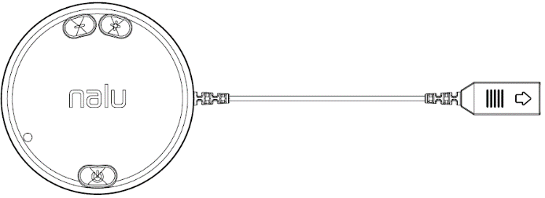
Description: |  | Case
Material: |  | Polycarbonate/Acrylonitrile Butadiene Styrene
Diameter: |  | 3” / 76 mm
Thickness: |  | 0.6” / 15 mm
Weight: |  | <100g
Description: |  | Cable
Material: |  | Polyvinyl Chloride
Connector: |  | Micro HDMI
Connector Length: |  | 5”/ 127 mm

Electrode Interfacing Cable – # 34003 |  | 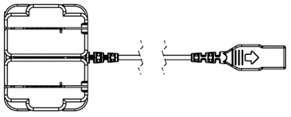
Unit: | Housing
Material: | Acrylonitrile Butadiene Styrene
Length: | 27”/ 69 cm
Description: | Cable
Material: | Polyvinyl Chloride
Connector: | Micro HDMI

Adhesive Clip Pack (H200) – # 74017-001 |  | 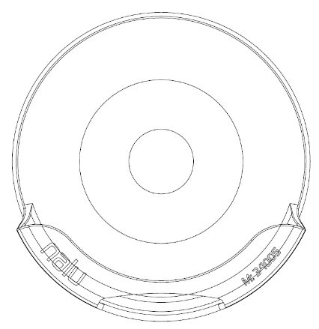
Description: | Clip
Material: | Polypropylene
Diameter: | 2.5”/ 62 mm
Description: | Adhesive
Material: | Hydrocolloid
Weight: | 9 g

Adhesive Clip Pack (H300) – # 74017-003 |  | Adhesive Clip Pack (H100) – # 74017-002
Description: | Clip | Description: | Clip
Material: | Polypropylene | Material: | Polypropylene
Diameter: | 2.5”/ 62 mm | Diameter: | 2.5”/ 62 mm
Description: | Adhesive | Description: | Adhesive
Material: | Hydrocolloid | Material: | Hydrocolloid
Weight: | 9 g | Weight: | 9 g

Relief Belt – # 34016
Description: | Belt | Description: | Buckle
Material: | Neoprene | Material: | Acetal
Length: | 48”/ 122 cm | Weight: | 69 g

Limb Cuff – # 34019
Description: | Cuff | Description: |  | Velcro
Material: | Neoprene | Material: |  | Acetal
Length: | 18”/ 46 cm | Weight: |  | 33 g

Thigh Wrap # 34018
Description: | Cuff | Description: | Velcro
Material: | Neoprene | Material: | Acetal
Length: | 25”/ 64 cm | Weight: | 40 g

Trial Therapy Disc Charger – # 43001
  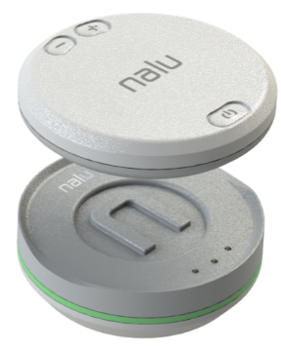 | 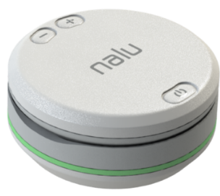
Description: | Case
Material: | Acrylonitrile Butadiene Styrene
Diameter: | 3”/ 76 mm
Weight: | 67 g

Base Station Charger – # 43012 |  | 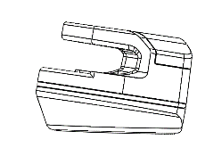  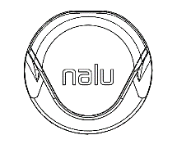
Description: | Case
Material: | Acrylonitrile Butadiene Styrene
Diameter: | 2.9”/ 74.5 mm
Weight: | 80.5 g

Radiofrequency (RF) and Wireless Data Parameters
Bluetooth® Low Energy (BLE) – Clinician Programmer, Remote Control, Therapy Disc, Base Station Charger
Industrial, Scientific, & Medical (ISM) – Therapy Disc, Nalu Implantable Pulse Generator
Qi Inductive Charging – Therapy Disc, Base Station Charger
Near-Field Communication (NFC) – Therapy Disc, Base Station Charger
WiFi – Base Station Charger

Parameter Band Description
Frequency BLE 2.402-2.480 GHz (data) ISM 40.66-40.70 MHz (power and data transfer)
WiFi 2.402-2.480 GHz, 5.150-5.850 GHz
Qi 100-200 kHz
NFC 13.553-13.567 MHz
Bandwidth BLE 2MHz ISM 1 MHz (low-depth amplitude modulation)
WiFi 160 MHz max
Qi < 10 kHz
NFC 14 kHz
Power BLE 10 dBm max ISM -14.1dBm max EIRP (330 mW max conducted)
WiFi 23 dBm max
Qi 10 W max conducted
NFC 420 mW max conducted
Data transfer BLE 1000-2000 kbps, 6ms latency, CRC, encryption ISM 250kbps, 32-bit CRC protection
WiFi 160 Mbps, 32-bit CRC protection, encryption
Qi N/A
NFC 848 kbits/s, ASK/subcarrier load modulation

Effective Range BLE <3meters ISM <3 cm
WiFi < 30 m
Qi < 5 mm
NFC < 5 mm
FCC ID
Therapy Disc | FCC ID: 2AMB3-34001-001  Contains FCC ID: 2AAQS-ISP1807
Trial Therapy Disc | Contains FCC ID: 2AAQS-ISP1507
Base Station Charger | FCC ID: 2AMB3-BSC  Contains FCC ID: 2AEMI-P2

Classification per IEC 60601-1: Therapy Disc and Trial Therapy Disc
In Use | Type BF
Charging | Class II

Quality of Service for Wireless Technology
The Nalu system makes use of several wireless functions during normal operation and for recharging the battery. Detailed wireless parameters are listed in the RF and Wireless Parameters section. Between the Therapy Disc and the IPG, a wireless connection is established using the ISM band. This is a short-range link that powers and communicates with the IPG.

Bluetooth Smart wireless technology enables communication between the Remote Control App, Clinician Programmer, and the Therapy Disc. The requirements for the quality of service (QoS) vary depending on the use environment (operating room, recovery room, and home environment).

After the Clinician Programmer or Remote Control App is paired with a Therapy Disc, the Bluetooth wireless technology symbol is visible on the app in the upper right-hand corner of the screen. When the Bluetooth Smart wireless technology connection is not active, the symbol appears dimmed. The standard Bluetooth Smart wireless technology data rate is 1 Mbit/s. Other requirements include a semi-duplex transmission with a required acknowledge, a transmission latency in each direction (2x), and a receive-to-transmit mode (RX-to-TX) time. Data is resent if not sent successfully.

The Base Station Charger uses an inductive charging link using a short-range Qi protocol to recharge the battery on the Therapy Disc. The Base Station Charger also incorporates optional near-field communication (NFC) technology, a BLE link, and a Wi-Fi connection. Qi and NFC are short-range links that operate when the Therapy Disc is inside the charger. NFC, BLE, and Wi-Fi are used to collect non-identifying device information.

When using wireless technology in the presence of high interference, the user may experience delays or disruptions to wireless services. For information on how to improve connection issues, refer to the Troubleshooting for Wireless and Coexistence Issues section. The recommended separation distance frequency bands are described in Guidance and Manufacturer’s Declaration.

Wireless Security Measures
- A description of wireless security measures is provided in the Cybersecurity section of this document.

Troubleshooting for Wireless and Coexistence Issues
If you experience issues with the wireless communication, try the following:
- Decrease the distance between the devices to ensure that the devices are within their effective range.
- Move the devices so they share line of sight
- Move the devices away from other devices that may be causing interference
- Wait a few minutes and try connecting again
- Do not operate other wireless devices (i.e. laptop, tablet, mobile phone, or cordless phone) at the same time
NOTE: Wireless communications equipment, such as wireless home network devices, mobile and cordless telephones, and tablets, can affect the device.

Statement of FCC Compliance (FCC ID: 2AMB3-34001-001, FCC ID: 2AMB3-BSC)
This equipment has been tested and found to comply with the limits for a Class B digital device, pursuant to part 15 of the FCC rules. These limits are designed to provide reasonable protection against harmful interference in a residential installation. This equipment generates, uses, and can radiate radiofrequency energy and, if not installed and used in accordance with the instructions, may cause harmful interference to radio communications. However, there is no guarantee that interference will not occur in a particular installation. If this equipment does cause harmful interference to radio or television reception, which can be determined by turning the equipment off and on, the user is encouraged to try to correct the interference by one or more of the following measures:
- Reorient or relocate the receiving antenna.
- Increase the separation between the equipment and receiver.
- Connect the equipment into an outlet on a circuit different from that to which the receiver is connected.
- Consult the dealer or an experienced radio/TV technician for help.
This device complies with Part 15 of the FCC Rules. Operation is subject to the following two conditions:
- This device may not cause harmful interference, and
- This device must accept any interference received, including interference that may cause undesired operation. Please note that changes or modifications not expressly approved by the party responsible for compliance could void the user’s authority to operate the equipment.
Changes or modifications not expressly approved by the party responsible for compliance could void the user’s authority to operate the equipment.
RF Exposure Statement (FCC ID: 2AMB3-34001-001)
This equipment complies with FCC radiation exposure limits set forth for an uncontrolled environment. This transmitter must not be co-located or operating in conjunction with any other antenna or transmitter. This equipment can safely operate at distances of <50 mm between the antenna and the body. Users must follow the specific operating instructions for satisfying RF exposure compliance.

RF Exposure Statement (FCC ID: 2AMB3-BSC)
This equipment complies with FCC radiation exposure limits set forth for an uncontrolled environment. This transmitter must not be co-located or operating in conjunction with any other antenna or transmitter. In order to avoid the possibility of exceeding the FCC radio frequency exposure limits, this equipment should be installed and operated with minimum distance 20 cm (7.9 inches) between the antenna and your body during normal operation. Users must follow the specific operating instructions for satisfying RF exposure compliance.

GUIDANCE AND MANUFACTURER'S DECLARATION
Electromagnetic Emissions
The Nalu Neurostimulation System is intended for use in the electromagnetic environment specified below. The customer or the user of the Nalu Neurostimulation System should assure that it is used in such an environment
Emissions test | Compliance | Electromagnetic Environment- Guidance
Radiofrequency (RF)  Emissions 1 | Group 2 | The Nalu Neurostimulation System must emit electromagnetic energy in order to perform its intended function. Nearby equipment may be affected.
RF Emissions  CISPR 11 | Class B | The Nalu Neurostimulation System is suitable for use in all establishments, including domestic establishments and those directly connected to the public low voltage power supply network that supplies buildings used for domestic purposes.
Harmonic emissions IEC 61000-3-2 | Class B
Voltage fluctuations/ flicker emissions IEC 61000-3-3 | Complies
CISPR 14-1 | Complies | The Therapy Disc is not intended to be connected to other equipment except the Charger. The Trial Therapy Disc is not intended to be connected to other equipment except the Electrode Interfacing Cable and Charger.

GUIDANCE AND MANUFACTURER'S DECLARATION
Electromagnetic Immunity
The Nalu Neurostimulation System is intended for use in the electromagnetic environment specified below. The customer or the user of the Nalu Neurostimulation System should assure that it is used in such an environment. The device does not have essential performance, but the performance of the device was tested for immunity.
Immunity Test | IEC 60601 Test Level | Compliance | Electromagnetic Environment- Guidance
Conducted RF  IEC 61000-4-6 | 3 Vrms  150 kHz to 80 MHz | 3 V | Portable and mobile RF communications equipment should be used no closer to any part of Nalu Neurostimulation System, than 0.2 meter, based on transmitters of 80 MHz to 2.5 GHz.
Radiated RF  IEC 61000-4-3 | 3 V/m  80 MHz to 2.5 GHz | 3 V/m | Interference may occur in the vicinity of equipment marked with the following symbol: 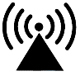
Electrostatic discharge (ESD) | IEC 61000-4-2 | ± 6 kV contact ± 8 kV air | Floors should be wood, concrete or ceramic tile. If floors are covered with synthetic material, the relative humidity should be at least 30%.
Electrical fast transient/burst IEC 61000-4-4 | ± 2 kV for power supply lines ± 1 kV for input/output lines | Pass | Mains power quality should be that of a typical commercial or home environment
Surge IEC 61000-4-5 | ± 1 kV line(s) to line(s) ± 2 kV line(s) to earth |  | Mains power quality should be that of a typical commercial or home environment
Voltage dips, short interruptions and voltage variations on power supply | input lines IEC 61000-4-11 95% dip in UT) for 0.5 cycle 40% UT (60% dip in UT) for 5 cycles 70% UT (30% dip in UT) for 25 cycles 95% dip in UT) for 5 s NOTE UT is the a.c. mains voltage prior to application of the test level. |  | Mains power quality should be that of a typical commercial or home environment
Power frequency (50/60 Hz) magnetic field IEC 61000-4-8 | 3 A/m |  | Power frequency magnetic fields should be at levels characteristic of a typical location in a typical commercial, hospital, or home environment.

Recommended Separation Distances Between Portable and Mobile
Radiofrequency (RF) Communications Equipment and the Nalu Neurostimulation System
The Nalu Neurostimulation System is intended for use in an electromagnetic environment in which radiated RF disturbances are controlled. The customer or user of the Nalu Neurostimulation System can help prevent electromagnetic interference by maintaining a minimum distance between portable and mobile RF communications equipment (transmitters) and the System.
Rated maximum output  power of transmitter  (W) | Separation distance according to frequency of transmitter
Rated maximum output  power of transmitter  (W) | 150 kHz to 80 MHz | 80 MHz to 800 MHz | 800 MHz to 2.5 GHz
0.01 | 0.12 m | 0.12 m | 0.45 m
0.1 | 0.37 m | 0.37 m | 1.41 m
1 | 1.17 m | 1.17 m | 4.47 m
10 | 3.70 m | 3.70 m | 14.12 m
100 | 11.70 m | 11.70 m | 44.65 m

Cybersecurity
Nalu employs comprehensive and detailed security practices to protect the system and its users from cybersecurity threats. During the product development lifecycle, potential vulnerabilities are identified through threat modeling, analysis, and penetration testing to ensure that the security design and countermeasures are adequately robust. After the product is deployed, Nalu continuously monitors for and responds to new vulnerabilities and security events to address evolving threats and exploits.
Guidelines for Secure Use
There are no cybersecurity controls for the Nalu Neurostimulation System that require user configuration or user infrastructure support (e.g., no anti-malware software, use of firewall). The Nalu Neurostimulation System is a closed system where security controls are implemented and monitored by Nalu. Devices are shipped in a secure configuration where communication is protected/encrypted in compliance with regulatory guidelines and industry standards as applicable. Guidelines for secure use of the remote control and programmer are provided in the corresponding user guides.
Wireless Security Measures
Communication between devices within the Nalu Neurostimulation System (i.e., remote control, programmer, therapy disc, base station charger) use wireless signals that are secured through device system design that includes the following:
- The wireless communication between devices is encrypted.
- Only one central device (e.g., remote control) may communicate with a peripheral device (e.g., Therapy Disc) at the same time.
- A unique key is used to establish each wireless connection.
- Built-in pairing that specifies valid and legitimate pairing among units.
- Proprietary authentication in addition to the pairing procedure specified in Bluetooth Smart wireless technology.
- A proprietary algorithm that detects and prevents an unauthorized user from attempting to communicate with the peripheral device (e.g., Therapy Disc).
Data Security
All patient data communicated and stored by the Nalu Neurostimulation System is encrypted in transit and at rest in compliance with regulatory guidelines and industry standards. Nalu employs backup and restore methods for patient data and configurations. Please see the remote control application user guide for more information regarding uninstalling the application and removing confidential data from your device.
Security Event Monitoring
Nalu actively monitors security events recorded by the Nalu Neurostimulation System that might indicate cybersecurity breaches or an issue with the system. A Nalu representative will notify you if software updates are required due to a security event or if the system should no longer be used. If you suspect that a cybersecurity event has occurred, then stop using the system and contact technical support.
Application Updates
Information on updating your remote control software is provided in the remote control application user guide. A Nalu Representative will notify you if your therapy discs require a firmware update, and the representative will install the update with their programmer.

Contact Information


Nalu Medical, Inc.
2320 Faraday Ave Ste 100
Carlsbad, CA 92008
Telephone: +1-800-618-3402
Customer Service: info@nalumed.com
Technical Support: support@nalumed.com
www.nalumed.com


This product can expose you to chemicals including ethylene oxide, which is known to the State of California to cause cancer and birth defect or other reproductive harm. For more information, go to www.P65Warnings.ca.gov.

Caution: Federal law restricts this device to sale by or on the order of a physician

Nalu is a trademark of Nalu Medical, Inc. Bluetooth is a registered trademark of Bluetooth sig, Inc.

